

Corporate finance

Table of Contents
Analysis of Financial Statements 1
Recording Business Activity 1
Financial Reports 1
The balance sheet 1
The income statement 4
The statement of cash flows 5
The statement of retained earnings 5
How do investors use financial statements? 6
Working (Operating) Capital 6
Operating Cash Flows 6
Free Cash Flow 6
Economic Value Added (EVA) 7
Financial Statement (Ratio) Analysis 7
Liquidity Ratios 7
Asset Management Ratios 7
Debt Management Ratios 8
Probability ratios 9
Market Value ratios 9
Trend Analysis 9
Summary of Ratio Analysis: The DuPont Analysis 9
Comparative Ratios (Benchmarking) 10
Uses and Limitations of Ratio Analysis 10
Financial Markets and the Investment Banking Process 11
What are Financial Markets? 11
Importance of Financial Markets 11
Flow of Funds 11
Market Efficiency 11
Types of Financial Markets 12
Money Markets vs Capital Markets 12
Debt Markets vs Equity Markets 12
Primary Markets vs Secondary Markets 12
Derivatives Markets 13
Stock Markets 13
Types of General Stock Market Activities 13
Physical stock exchanges 14
Exchange members 14
Listing Requirements 14
Over-the-counter market 14
Competition Among Stock Markets 15
Regulation of Securities Markets 15
The Investment Banking Process 15
Raising Capital: Stage I Decisions 16
Raising Capital: Stage II Decisions 16
Selling Procedures 16
Shelf Registrations 17
Maintenance of the Secondary Market 17
International Financial Markets 17
Financial Intermediaries and Their Roles in Financial Markets 17
Types of Financial Intermediaries 17
Financial Organizations in Other Parts of the World 18
The Time Value of Money 19
Future Value 19
Financial Calculator Solution 19
Present Value 20
Comparison of Future Value with Present Value 20
Annuity Payments 21
Future Value of an Annuity, FVA 21
Future Value of an Ordinary Annuity 21
Future Value of Annuity Due, FVA(DUE) 21
Present Value of an Annuity, PVA 21
Present Value of an Annuity Due, PVA(DUE) 22
Computing Annuity Payments (PMT), Interest Rates (r), and Time (n) 22
Perpetuities 22
Uneven Cash Flow Streams 22
Future Value of an Uneven Cash Flow Stream 23
Semiannual and Other Compounding Periods 23
Comparison of Different Interest Rates 23
The Cost of Money (Interest Rates) 26
Realized Returns (Yields) 26
Factors That Affect the Cost of Money 26
Interest Rate Levels 27
The Determinants of Market Interest Rates 27
The nominal (quoted) risk-free rate of interest r_{RF} 27
The real risk-free rate (r*): 27
Inflation Premium (IP) 28
Default Risk Premium (DRP) 28
Liquidity Premium (LP) 28
Maturity Risk Premium (MRP) 28
The Term Structure of Interest Rates 29
Why do Yield Curves Differ? 29
Does the Yield Curve Indicate Future Interest Rates? 30
Other Factors the Influence Interest Rate Levels 30
Federal Reserve Policy 30
Federal Deficits 31
International Business (Foreign Trade Balance) 31
Business Activity 32
Interest Rate Levels and Stock Prices 32
The Cost of Money as a Determinant of Value 32
Bonds (Debt) – Characteristics and Valuation 34
Debt Characteristics 34
Principal Value, Face Value, Maturity Value, and Par Value 34
Interest Payments 34
Maturity Date 34
Priority to Assets and Earnings 34
Control of the Firm (Voting Rights) 34
Types of Debt 34
Short-Term Debt 34
Long-Term Debt 35
Rates of Return on Different Types of Debt 37
Bond Contract Features 37
Bond Indenture 37
Call Provision 37
Sinking Fund 37
Convertible Feature 37
Bond Ratings 37
Bond Rating Criteria 38
Importance of Bond Ratings 38
Foreign Debt Instruments 38
Valuation of Bonds 39
The Basic Bond Valuation Model 39
Finding Bond Yields (Market Rates): Yield to Maturity and Yield to Call 39
Yield to Maturity 39
Yield to Call 40
Interest Rates and Bond Values 40
Changes in Bond Values over Time 40
Bond Values with Semiannual Compounding 41
Interest Rate Risk on a Bond 41
Stocks (Equity) – Characteristics and Valuation 42
Preferred Stock 42
Par Value 42
Cumulative Dividends 42
Maturity 42
Priority to Assets and Earnings 42
Control of the Firm (Voting Rights) 42
Convertibility 42
Other Provisions 42
Common Stock 43
Par Value 43
Dividends 43
Maturity 43
Priority to Assets and Earnings 43
Control of the Firm (Voting Rights) 44
Preemptive right 44
Types of Common Stock 44
Equity Instruments in International Markets 44
American Depository Receipts (ADRs) 45
Foreign Equity (Stock) 45
Stock Valuation – Dividend Discount Model (DDM) 45
Definitions of Terms Used in the Stock Valuation Models 45
Expected Dividends as the Basis for Stock Values 45
Valuing Stock with Zero Growth 46
Valuing Stocks with Constant (Normal) Growth 46
Expected Rate of Return on a Constant Growth Stock 47
Valuing Stocks with Nonconstant Growth 47
Other Stock Valuation Methods 48
Valuation Using P/E Ratios 48
Evaluating Stocks Using the Economic Value Added Approach 48
Changes in Stock Prices 49
Risk and Rates of Return 50
Defining and Measuring Risk 50
Probability Distributions 50
Expected Rate of Return 50
Continuous versus Discrete Probability Distributions 50
Measuring Total (Stand-Alone) Risk: The Standard Deviation 51
Coefficient of Variation (Risk/Return Ratio) 51
Risk Aversion and Required Returns 52
Portfolio Risk – Holding Combinations of Assets 52
Portfolio Returns 52
Portfolio Risk 52
Firm-Specific Risk versus Market Risk 53
The Concept of Beta (ß) 53
Portfolio Beta Coefficients 54
The Relationship Between Risk and Rates of Return (CAPM) 54
The Impact of Inflation 55
Changes in Risk Aversion 55
Changes in a Stock’s Beta Coefficient 56
A Word of Caution 56
Stock Market Equilibrium 56
Different Types of Risk 56
Capital Budgeting Techniques 58
Importance of Capital Budgeting 58
Generating Ideas for Capital Projects 58
Project Classifications 58
Similarities Between Capital Budgeting and Asset Valuation 58
Net Present Value (NPV) 59
Internal Rate of Return (IRR) 60
Comparison of the NPV and IRR Methods 61
NPV Profiles 61
NPVs and the Required Rate of Return 61
Independent Projects 61
Mutually Exclusive Projects 62
Cash Flow Patterns and Multiple IRRs 62
Modified Internal Rate of Return 62
Payback Period – Traditional (Nondiscounted) and Discounted 63
Conclusions on the Capital Budgeting Decision Methods 64
The Postaudit 64
Project Cash Flows and Risk 66
Cash Flow Estimation 66
Relevant Cash Flows 66
Cash Flow versus Accounting Income 66
Incremental Cash Fl 66
Beyond Incremental Cash Flows 67
Initial Investment Outlay 67
Incremental Operating Cash Flows 68
Terminal Cash Flow 68
Capital Budgeting Project Evaluation 68
Expansion Project 68
Replacement Analysis 69
Incorporating Risk in Capital Budgeting Analysis 69
Stand-Alone Risk 70
Sensitivity Analysis 70
Scenario Analysis 70
Monte Carlo Simulation 71
Corporate (Within-Firm) Risk 71
Beta (Market) Risk 71
Beta (Market) Risk and Required Rate of Return for a Project 71
Measuring Beta Risk for a Project 72
Project Risk Conclusions 72
How Project Risk is Considered in Capital Budgeting Decisions 72
Capital Rationing 73
Multinational Capital Budgeting 73

Analysis of Financial Statements

Financial statement analysis involves analysis of a firm’s financial position to identify its current strengths and weaknesses and to suggest actions that the firm might pursue to take advantages of those strengths and correct any weaknesses.

Recording Business Activity
Accounting was born 4,000 years ago in Mesopotamia as the result of the Code of Hammurabi, which required merchants to provide prices of goods and services in writing in order to record sales agreements.
Modern accounting began in the 15th century when Benedetto Cotrugly introduced the double-entry bookkeeping system, which was more formally developed by Luca Pacioli a few decades later.
According to Pacioli, to be successful, a merchant must have access to funds (cash or credit) to support daily operations and a system that permits a merchant to easily determine his financial position. He further recommended that merchants record all assets and liabilities, both person and business, before starting business, and he noted that these records should be kept current.

Financial Reports
Annual report: This, arguably most important, report describes the firm’s operating results during the past year and discusses new developments that will affect future operations and gives an accounting picture of the firm’s operations and financial position.

This report provides 2 types of information:
- It includes a verbal section, often presented as a letter from the chairman, that describes the firm’s operating results during the past year and discusses new developments that will affect future operations
- It presents 4 basic financial statements
The balance sheet
    - The balance sheet represents a picture taken at a specific point in time that shows a firm’s assets and how those assets are financed.
      - Assets, which represent the firm’s investments, are classified as
        - Current assets (Short-term)
          - Current assets generally include items that will be liquidated within one year
        - Fixed assets (Long-term)
          - Fixed assets generally include investments that help generate cash flows over longer-periods
        - To finance their assets, firms issue debt, equity, or both.
          - Debt represents the loans the firm has outstanding and generally divided into:
            - Short-term debt (Current Liabilities)
              - Includes accounts payable, accruals, and notes payable.
              - Represents debt that is due within one year
            - Long-term debt
              - Includes bonds and similar debt instruments
              - Paid off over a period longer than one year
      - Equity represents stockholders’ ownership, which does not have to be paid off. Total equity is the amount to be paid to stockholders if the firm’s assets could be sold at the values reported on the balance sheet.
        - Common stockholders’ equity (net worth) = Total Assets – Total Liabilities
        - If asset value rises, benefits accrue exclusively to stockholders
        - The change in the firm’s net worth is reflected by changed in the retained earnings account
          - If bad debts are written off in the asset section of the balance sheet, the retained earnings balance is reduced in the equity section
          - Retained earnings: An account that effectively represents the total amount of income a company has saved and reinvested in assets since it started business. It shows the cumulative amount of income the company has kept rather than paid out as dividends over the years
      - Assets are listed in order of liquidity. The claims are listed in the order in which they must be paid.
        - Accounts payable ~ 30-45 days
        - Accruals ~ 60-90 days
        - Stockholders’ equity must never be paid off.
      - Assets, liabilities, and equity can be stated both in $ and as a % of total assets.
        - Common size balance sheet: Items on a balance sheet that are stated as percentages
    - Additional points about the balance sheet:
      - Cash and equivalents versus other assets
        - Although assets are stated in $, only the cash and equivalents account represents actual money that can be spent.
        - Receivables are bills owed to you
        - Inventories show the dollars that the company has invested in raw materials, work-in-process, and finished goods available for sale
        - Net fixed assets reflect the amount of money paid for plant and equipment less depreciation since acquisition
      - Accounting alternatives
        - FIFO (First in, first out)
          - During a period of rising prices, compared with LIFO, FIFO will produce a higher balance sheet inventory value but a lower COGS, thus a higher net income
        - LIFO (last in, first out)
        - Companies generally use the most accelerated method permissible to calculate depreciation for tax purposes because accelerated methods lower taxable incomes and thus taxes that must be paid
          - They may use straight-line depreciation for constructing financial statements reported to stockholders because this method results in higher net incomes
      - Breakdown of the common equity account
        - This section includes three accounts:
          - Common stock at par = Total shares issued $×$ Share per value
          - Paid-in capital
            - The amount that was paid above the par value is reported here
            - Multiply portion of selling price per share that exceeds the stock’s par value by the number of shares issued
          - Retained earnings
        - When a firm issues common stock to raise funds to invest in assets, the amount that investors pay for the stock must be reported in the equity section of the balance sheet. Because common stock does not have a par value, the entire amount of the issue is reported in the common stock account
      - Book values versus market values
        - Book values: The values, or accounting numbers, that are reported on the balance sheet and are generated using GAAP
        - Market values: The prices (values) for which assets can actually be sold in the marketplace
        - The equity section of the balance sheet must equal the book value of assets – the book value of liabilities
          - It is likely that book values of assets differ from their market values, but it is likely that the book values of liabilities are close to their market values.
      - The time dimension
        - The balance sheet can be thought of as a snapshot of the firm’s financial position at a point in time. The balance sheet changes every day as inventories are increased or decreased, as fixed assets are added or retired, as liabilities are increased or decreased, etc.
The income statement
    - The income statement, which is also referred to as the profit and loss statement, presents the results of business operations during a specific period of time such as a quarter or a year and summarizes the revenues generated and the expenses incurred by the firm during the accounting period.
      - Net sales are shown at the top of the statement, followed by various costs, including income taxes, that are subtracted to determine the net income (earnings) available to common stockholders.
      - A report on earnings and dividends per share appears at the bottom of the statement
      - In managerial finance EPS is called the bottom line because EPS is often considered the most important item on the income statement
    - Firms financed with debt will have greater tax-deductible expenses as a result of the interest expense and thus will report a lower net income that firms financed with only equity
      - When comparing the operations of 2 firms, you should examine Net Operating Income (NOI)
        - AKA EBIT because this figure represents the result of normal operations before considering the effects of the firm’s financial structure
    - The income statement is generated using the accrual method of accounting
      - Revenues are recognized when they are earned, not when cash is received
      - Expenses are recognized when incurred, not when the cash is paid
      - Although the firm’s net income is important, cash flows are more important, thus we focus on cash flow rather than net income
      - When a firm sells its products for cash and pays for all the expenses reported on its income statement, except depreciation and amortization, its net cash flow can be computed as follows:
        - Net cash flow = Net income + Depreciation and amortization
    - Operating cash flows arise from normal operations, and represent the difference between cash collections and cash expenses, including taxes paid, associated with the manufacture and sale of inventory
    - Accounting profits: the operating income of a company
    - Operating cash flows can differ from accounting profits because:
      - A firm can sell on credit
      - Some operating expenses are not cash costs, like depreciation and amortization expenses.
    - Analysts often computer a firm’s EBITDA (earnings before interest, taxes, depreciation, and amortization) when evaluating its operation. EBITDA provides an indication of the cash flows that are generated by normal operations.
The statement of cash flows
    - The statement of cash flows is designed to show how the firm’s operations have affected its cash position by examining the firm’s investment decisions (uses of cash) and financing decisions (sources of cash)
    - To determine whether a change in a balance sheet account was a source or a use of cash:
Sources of Cash | Uses of Cash
Increase in a Liability or Equity Account | Decrease in a Liability or Equity account
Borrowing funds or selling stock provides the firm with cash | Paying off a loan or buying back stock uses cash
Decrease in an Asset Account | Increase in an Asset Account
Selling inventory or collecting receivables provides cash | Buying fixed assets or buying more inventory uses cash

    - Operating cash flows are those associated with the production and sale of goods and services.
      - The estimate of cash flows obtained from the income statement is the primary operating cash flow, but changes in accounts payable, accounts receivable, inventories, and accruals are also classified as operating cash flows because these accounts are directly affected by the firm’s day-to-day operations.
      - Investment cash flows arise from the purchase or sale of plant, property, and equipment
      - Financing cash inflows result when the firm pays dividends, repays debt (loans), or repurchases stock
      - The cash inflows and outflows from these 3 activities are summed to determine their effect on the firm’s liquidity position, which is measured by the change in the cash and equivalents account from one year to the next.
The statement of retained earnings
    - The statement of retained earnings shows changes in the common equity accounts between balance sheet dates.
      - Retained earnings account represents a claim against assets.
      - Changes in retained earnings represent the recognition that income generated by the firm during the accounting period was reinvested in various assets rather than paid out as dividends to stockholders. As a result, the amount of retained earnings as reported on the balance sheet does not represent cash and is not available for the payment of dividends or anything else.

How do investors use financial statements?

Working (Operating) Capital
Working capital generally refers to a firm’s current assets because investment in these assets is necessary to keep the firm’s day-to-day operations working. They are often termed spontaneous assets because their values change on a daily basis as a result of normal operations.
These liabilities are often termed spontaneously generated funds, or spontaneous liabilities because they change spontaneously as the firm’s normal operations change.
Investors are interested in a firm’s operating capital for 2 reasons:
- Short-term financing arrangements must be paid off in the short term
- Short-term investments generally earn a lower return than long-term investments

Net working capital = NWC = Current assets – Current Liabilities

Net operating working capital = NOWC = (Current assets required for operations) – (Non-interest-bearing current liabilities)

Operating Cash Flows
Another measure that needs to be examined is the operating cash flow generated by a firm.

Operating cash flow = NOI (1 - Tax Rate) + Depreciation and amortization expense
= Net operating profit after taxes + “ “

Free Cash Flow
Free cash flow measures the cash flow that the firm is free to pay to investors (both bondholders and stockholders) after considering the cash investments that are needed to continue operations, including investments in fixed assets needed to manufacture products, working capital needed to continue operations, and new opportunities that will grow the stock price.

Free cash flow = FCF = Operating cash flow – Investments
= Operating cash flow – (∆ in fixed assets + ∆ NOWC)

Economic Value Added (EVA)
The economic value added (EVA) measure is based on the concept that the earnings from actions taken by a company must be sufficient to compensate the suppliers of funds, both the bondholders and the stockholders.
The computation of net income includes interest expense, which is a reflection of the cost of debt, but the dividends paid to stockholders, which is an indication of the cost of equity, are recognized after net income is determined. The general concept underlying EVA is to determine how much a firm’s economic value is increased by the decisions it makes.

EVA = NOI (1 – Tax rate) – [(Invested capital) $×$ (After-tax cost of capital as a %)]

Here invested capital is the amount of funds provided by investors and the cost of capital is the rate of return associated with this capital. The EVA measure gives an estimate of the true economic profit generated. + EVA = actions of firm should increase value, - EVA = actions of firm should decrease value.

Financial Statement (Ratio) Analysis
The real value of financial statement lies in the fact that they can be used to help predict the firm’s financial position in the future and to determine expected earnings and dividends.

Liquidity Ratios
A liquid asset is one that can be easily converted to cash without significant loss of its original value. Two commonly used liquidity ratios (a ratio analysis that provides a quick, easy-to-use measure of liquidity by relating the amount of cash and other current assets to the firm’s current obligation) are:
- The current ratio = Current Assets / Current Liabilities
  - Current assets normally include cash & equivalents, account receivable, and inventories
  - Current liabilities consist of account payable, short-term notes payable, long-term debt that matures in the current period, accrued taxes, and other accrued expenses
- The quick (acid test) ratio = (Current assets – Inventory) / Current liabilities

Asset Management Ratios
The asset management ratios measure how effectively the firm is managing its assets.

Inventory Turnover Ratio = COGS / Inventory = Variable operating cost / Inventory

Days Sales Outstanding = Accounts Receivable / Average Daily Sales = Accounts Receivable / (Annual Sales / 360)

DSO, also called the Average Collection Period (ACP), is used to evaluate the firm’s ability to collect its credit sales in a timely manner

Fixed Assets Turnover Ratio = Sales / Net Fixed Assets
The fixed assets turnover ratio measures how effectively the firm uses its plant and equipment to help generate sales.

Total Asset Turnover Ratio = Sales / Total Assets

The total asset turnover ratio measures the turnover of all of the firm’s assets

Debt Management Ratios
The extent to which a firm uses debt financing has 3 important implications
- By raising funds through debt, the firm avoids diluting stockholder ownership
- Creditors look to the equity, or owner-supplied funds, to provide a margin of safety. If the stockholders have provided only a small portion of the total financing, the risks of the enterprise are borne mainly by its creditors
- If the firm earns more on investments financed with borrowed funds than it pays in interest, the return on the owners’ capital is leveraged.

Financial leverage: Borrowing that affects the expected rate of return realized by stockholders because the interest on debt is tax deductible whereas dividends are not, so paying interest lowers the firm’s tax bill, ceteris paribus. The rate a firm earns from its investments in assets usually differs from the rate at which it borrows.
- The cost (interest payments) associated with borrowing are contractual and do not vary with sales, and they must be paid to avoid the threat of bankruptcy.
- If interest payments are high enough, a firm with a positive operating income could end up with a negative return to stockholders.
- Firms with relatively high debt ratios have higher expected returns when business is normal, but they are exposed to risk of loss when business is poor. Firms with low debt ratios are less risky, but forgo the opportunity to leverage up their return on equity.

Debt ratio = Debt-to-total-assets ratio = Total liabilities / Total assets

The debt ratio measures the percentage of the firm’s assets financed by creditors.
- Creditors prefer low debt ratios because the lower the ratio, the greater the cushion against creditors’ losses in the event of liquidation.
- Owners can benefit from leverage because it magnifies earnings, thereby increasing the return to stockholders.

Times-Interest-Earned ratio = EBIT / Interest charges

TIE measures the extent to which a firm’s EBIT, also called NOI, can decline before these earnings are unable to cover annual interest costs.
Because interest is paid with pre-tax $, the firm’s ability to pay current interest is not affected by taxes.

Fixed Charge Coverage Ratio = (EBIT + Lease Payments) / (Interest charges + Lease Payments + (Sinking fund payments / (1 – Tax Rate)))

Similar to the TIE, fixed charge coverage ratio, is more inclusive because it recognizes that many firms lease rather than buy assets and also must make sinking fund payments.
- Sinking fund payments must be paid with after-tax $, whereas interest and lease payments are paid with pre-tax $, the sinking fund payments must be divided by (1 – Tax Rate) to find the before-tax income required to pay taxes and still have enough left to make the sinking fund payment

Probability ratios
Probability ratios show the combined effects of liquidity management, asset management, and debt management on operating results.

Net Profit Margin = Net Profit / Sales

The net profit margin gives the profit per $ of sales.

Return on total asset = ROA = Net Income / Total Assets

Return on common equity = ROE = Net income available to common stockholders / Common Equity

ROE is also known as the rate of return on stockholders’ investment.

Market Value ratios
The market value ratios relate the firm’s stock price to its earnings and book vlue per share. They give management an indication of what investors think of the company’s future prospects based on its past performance.

The price/earnings (P/E) ratio shows how much investors are willing to pay per $ of reported profits. To compute, earnings per share must be known.

EPS = Net income available to common stockholders / Number of common shares outstanding

P/E = Market price per share / Earnings per share

Book value per share = Common equity / Number of common shares outstanding

Market/Book ratio = Market price per share / Book value per share

Trend Analysis
Trend analysis examines the paths taken in the past to provide information about whether the firm’s financial position is more likely to improve or deteriorate in the future.

Summary of Ratio Analysis: The DuPont Analysis

DuPont equation is used to attain greater detail by dissecting a single ratio into two or more related ratios. In the basic approach we compute the Return on Assets.

ROA = Net profit margin x Total assets turnover
= Net income / sales x Sales / Total assets

ROA is defined as net income available to common stockholders divided by total assets.

ROE = ROA x Equity Multiplies
= Net income / Sales x Total Assets / Common Equity

Extended DuPont equation:
ROE = (Profit Margin x Total assets turnover) x Equity Multiplier
= (Net income / Sales x Sales / Total assets) x Total assets / Common equity

The equity multiplier for the industry is computed as the inverse of the equity to total assets ratio (= 1 – Debt ratio)

Comparative Ratios (Benchmarking)

Comparative ratio analysis: the ratios calculated for a particular company compared with those of other firms in the same industry

Uses and Limitations of Ratio Analysis

Three main groups use ratio analysis:
- Managers
- Credit Analysts
- Security analysts (or investors)

Potential problems:
- Large firms operate a number of divisions in very different industries making it difficult to develop a meaningful set of industry averages for comparative purposes
- Most firms want to be better than average
- Inflation might distort firms’ balance sheets
- Seasonal factors can distort a ratio analysis
- Firms can employ window dressing techniques to make their financial statements look stronger
- Different accounting practices can distort comparisons
- It is difficult to generalize about whether a particular ratio is good or bad
- A firm might have some ratios that look good and others that look bad, making it difficult to tell whether the company is on balance, strong, or weak

The most important and most difficult input to successful financial statement (ratio) analysis is the judgment used when interpreting the results to reach an overall conclusion about the firm’s financial position.

Financial Markets and the Investment Banking Process

What are Financial Markets?

People and organizations that need money are brought together with those that have surplus funds in the financial markets.
- Physical asset markets deal with products such as wheat, autos, real estate, etc.
- Financial asset markets deal with stocks, bonds, mortgages, and other claims on real assets with respect to the distribution of future cash flows generated by such assets.
- Financial markets: A system consisting of individuals and institutions, instruments, and procedures that brings together borrowers and savers

Importance of Financial Markets

The primary role of financial markets is to facilitate the flow of funds from individuals and businesses that have surplus funds to individuals, businesses, and governments that have needs for funds in excess of their incomes. Financial markets help efficiently allocate these funds. The more efficient the funds flow, the more productive the economy, both in terms of manufacturing and financing.

Flow of Funds
By providing mechanisms by which borrowers and lenders get together to transfer funds, the financial markets allow us to consume amounts different from our current incomes.
- When we borrow we sacrifice future income to increase current income
- When we invest we sacrifice current income in exchange for greater expected income in the future.
Without financial markets, consumption would be restricted to income earned each year plus any amounts put aside in previous years. Standard of living would be lower.

Funds are transferred from savers to borrowers by 3 different processes:
- A direct transfer of money and securities occurs when a business sells its stocks or bonds directly to savers without going through any type of intermediary or financial institution.
- A transfer can go through an investment banking house, which serves as a middleman that facilitates the issuance of securities.
- A transfer can be made through a financial intermediary.

Market Efficiency
If the financial markets did not provide efficient funds transfers, the economy could not function as it does now. It is essential that markets function efficiently, which generally refers to:
- Economic efficiency: Funds are allocated to their optimal use at the lowest costs in the financial markets
  - Transaction costs are costs associated with buying and selling investments, including commissions, search costs, taxes, etc.
- Informational efficiency: The prices of investments reflect existing information and adjust quickly when new information enters the markets
  - Generally classified into one of 3 categories:
    - Weak-form efficiency states that all information contained in past price movements is fully reflected in current market prices
    - Semistrong-form efficiency states that current market prices reflect all publicly available information.
      - Abnormal returns: Returns that exceed those that are justified by the risks associated with the investments
    - Strong-form efficiency states that current market prices reflect all pertinent information, whether it is publicly available or privately held

Types of Financial Markets

Money Markets vs Capital Markets
- Money markets: The segments of the financial markets in which the instruments that are traded have maturities equal to one year or less
  - Short-term financial instruments
  - Include only debt
  - Primary function is to provide liquidity to businesses, governments, and individuals
- Capital markets: The segments of the financial markets in which the instruments that are traded have maturities greater than one year
  - Long-term financial instruments
  - Include both equity and long-term debt instruments
  - Individuals, corporations, and governments use these markets either to spend more than the funds generated in the current period in exchange for their ability to replay the additional funds (with interest) in future periods or to invest current income to enable greater consumption in the future

Debt Markets vs Equity Markets

- Debt markets: Financial markets in which loans are traded
  - Permit individuals, companies, and governments to consume future income in the current period through such loans as mortgages and corporate bonds.
- Equity markets: Financial markets in which corporate stocks are traded
  - Permit corporations to raise funds by selling ownership interests, thereby transferring some risks associated with businesses to individuals and other companies.

Primary Markets vs Secondary Markets

- Primary markets: Markets in which various organizations raise funds by issuing new securities
  - Markets in which “new” securities are traded
- Secondary markets: Markets in which financial assets that have previously been issued by various organizations are traded among investors
  - Markets in which “used” securities are traded
  - Also exist for mortgages, other types of loans, and other financial assets
  - Corporation whose securities are traded in the secondary market is not involved in the transaction and doesn’t receive any funds from the transaction

Derivatives Markets
- Derivatives markets: Financial markets in which options and futures are traded
  - Called derivatives because their values are derived directly from other assets
  - Call option: An option that allows the buyer to purchase stock (or some other security) from the option seller at a pre-specified price during a particular time period
    - Because the option contract fixes the purchase price of the stock, the value of the call option changes as the actual market value of the stock changes
  - Put option: An option that allows the buyer to sell stock (or some other security) from the option seller at a pre-specified price during a particular time period
  - Futures contract: A contract for the future delivery of an item where the price, amount, delivery date, place of delivery, etc. are specified

Stock Markets

Types of General Stock Market Activities
We can classify general stock market activities into 3 categories:
- Trading in the outstanding, previously issued shares of established, publicly owned companies; the secondary market
- Additional shares sold by established, publicly owned companies; the primary market
- New public offerings by privately held firms; the Initial Public Offering (IPO) market; the primary market
  - Going public: The act of selling stock to the general public for the first time by a corporation or its principal stockholders
  - Initial Public Offering (IPO): The market consisting of stocks of companies that have just gone public

Nearly all stock transactions occur in the secondary markets.

Traditionally, stock markets are categorized into one of two basic types:
Physical stock exchanges: formal organizations with physical locations that facilitate trading in designated securities
- Includes the NYSE, AMEX, CHX, etc.
- Prices listed on these exchanges are determined by auction process in which investors bid for stocks
- Demutualization: The process of converting a stock exchange from a mutual ownership organization to a stock ownership organization

Exchange members are charged with different trading responsibilities, depending on the type of license they own
- Floor brokers act as agents for investors who want to buy or sell securities.
House brokers are floor brokers who are employed by brokerage firms to execute orders for the firms’ clients
Independent brokers are freelance brokers who work for themselves or for firms that provide trading services to house brokers rather than for a brokerage firm
- Specialists are considered the most important participants in NYSE transactions because their role is to bring buyers and sellers together.
A specialist must be ready to make a market when either buyers or sellers are needed, thus a specialist must maintain inventories in the stocks they’ve been assigned
The specialist posts a bid and and ask price in an effort to keep the inventory in balance
Bid prices are somewhat lower than ask prices, with the spread, representing the specialist’s profit margin
On the NYSE, supply/demand imbalances require specialists to participate in buying or selling shares only about 10% of the time

Listing Requirements are characteristics a firm must posses to be listed on an exchange

Over-the-counter market: A collection of brokers and dealers, connected electronically by telephones and computers, that provides for trading in securities not listed on the physical stock exchanges
- Includes NASDAQ
- The exchanges operate as auction markets: buy and sell orders come in more or less simultaneously, and exchange members match these order
- The OTC market has been defined as including all facilities needed to conduct security transactions not conducted on the physical exchanges. These consist of
  - The dealers who hold inventories of OTC securities
  - The brokers who act as agents
  - The electronic networks that provide a communications link between dealers and brokers
- OTC does not operate as an auction market
  - The dealers who make a market in a particular stock continuously quote the bid and ask price
  - Each dealer’s prices are adjusted based on supply and demand conditions
  - The spread between the bid and ask represents the dealer’s markup
- The NASDAQ includes market makers who continuously monitor trading activities in various stocks to ensure such stocks are available to traders who want to trade them. The role of these market makers is similar to that of specialists on the NYSE
- Electronic Communications Networks (ECNs): Electronic systems that transfer information about securities transactions to facilitate the execution of orders by automatically matching buy and sell orders for a large number of investors
- In term of numbers of issues, most stocks are traded over the counter. However, most of these stocks involve small companies that do not meet the requirements to be listed on a physical exchange.
- Approximately 2/3 of the total dollar volume of stock trading takes place on the exchanges

Competition Among Stock Markets
Two factors have changed the competitive arena of the stock markets:
- Dual listing: When stocks are listed for trading in more than one stock market
  - Dual listing increases liquidity because a stock has more exposure through a greater number of outlets
- Trade-through rule: Requires a trade order to continue to pass through markets until the best price is reached
  - Objective is to provide investors equal access to various stock markets so they can trade at the best price

Regulation of Securities Markets

Securities and Exchange Commission (SEC): The U.S. government agency that regulates the issuance and trading of stocks and bonds.

The primary elements of the SEC regulations include:
- Jurisdiction over most interstate offerings of new securities to general investing public
- Regulation of national securities exchanges
- The power to prohibit manipulation of securities’ prices
- Control over stock trades by corporate insiders
  - Insiders: Officers, directors, major stockholders, or others who might have inside information about a company’s operations

The Investment Banking Process

Investment banker: An organization that underwrites and distributes new issues of securities; it helps businesses and other entities obtain needed financing. Such organization perform 3 types of tasks:
- They help corporations design securities with features that are most attractive to investors given existing market conditions
- They buy these securities from the corporations
- They resell the securities to investors

Investment banking deals with the issuance of new securities, not deposits and loans.

Raising Capital: Stage I Decisions
The corporation that needs to raise funds makes some preliminary decisions on its own:
- Dollars to be raised
- Type of securities used
- Competitive bid versus negotiated deal
- Selection of an investment banker

Raising Capital: Stage II Decisions
Stage II decisions, made jointly by the firm and its selected investment banker, include:
- Reevaluating the initial decisions
- Best efforts or underwritten issues
  - Underwritten arrangement: Agreement for the sale of securities in which the investment bank guarantees the sale by purchasing the securities from the issuer, thus agreeing to bear any risks involved in the transaction
  - Best efforts arrangement: Agreement for the sale of securities in which the investment bank handling the transaction gives no guarantee that the securities will be sold
- Issuance (floatation) costs
  - Underwriter’s spread: The difference between the price at which the investment banking firm buys an issue from a company and the price at which the securities are sold in the primary market. It represents the investment banker’s gross profit on the issue
  - Floatation costs: The costs associated with issuing new stocks or bonds
- Settings the offering price
  - Offering price: The price at which common stock is sold to the public

Selling Procedures
Registration statement: A statement of facts files with the SEC about a company that plans to issue securities.
Prospectus: A document describing a new security issue and the issuing company.

Underwriting syndicate: A group of investment banking firms formed to spread the risk associated with the purchase and distribution of a new issue of securities. The investment banking house that sets up the deal is called the lead, or managing, underwriter.
- Larger offerings might require the service of still more investment bankers as part of a selling group.
- Include minimum waiting period of 20 days.

Shelf Registrations: Securities registered with the SEC for sale at a later date; the securities are held on the shelf until the sale.

Maintenance of the Secondary Market
In the case of a company going public for the first time, the investment banker has an obligation to maintain a market for the shares after the issue has been completed. Such stocks are typically traded in the OTC market, and the lead underwriter generally agrees to make a market in the stock and keep it reasonably liquid.

International Financial Markets

Euroland: The countries that comprise the European Monetary Union (EMU).
- Officially born 1 January, 1999 with 11 member countries
- Financial markets truly are global in nature

Financial Intermediaries and Their Roles in Financial Markets

Financial intermediaries: Specialized financial firms that facilitate the transfer of funds from savers to borrowers

Financial intermediation: The process by which financial intermediaries transform funds provided by savers into funds used by borrowers

Improving economic well-being is one of the benefits associated with intermediaries. Others include:
- Reduced costs
- Risk diversification
- Funds divisibility/pooling
- Financial flexibility
- Related services

Types of Financial Intermediaries
Commercial Banks
Credit Unions A depository institution owned by its depositors
Thrift Institutions: Cater to savers
Mutual Funds Investment companies that accept money from savers and then use these funds to buy various types of financial assets
  - Investors who prefer to receive current income can invest in income funds
  - Investors who prefer higher risk/higher reward can invest in growth funds
  - Money market mutual fund: A mutual fund that invests in short-term, low-risk securities and allows investors to write checks against their accounts
Whole Life Insurance Companies A long-term contract that provides lifetime insurance
  - Term insurance is a relatively short-term contract that provides protection for a temporary period
  - Term insurance premiums increase with each renewal
  - Whole life Insurance premiums are fixed
Pension Funds Retirement plans funded by corporations or government agencies for their workers

Financial Organizations in Other Parts of the World

- Past regulation restricted the ability of financial institutions, especially intermediaries, to operate through branches
- Most foreign financial institutions are allowed to engage in nonbanking (nonfinancial) business activities whereas the nonbanking activities of US intermediaries have been severely restricted until recently

The Time Value of Money

The sooner a dollar is received the more quickly it can be invested to earn a positive return.

Time value of money (TVM): The principles and computations used to revalue cash payoffs at different times so they are stated in dollars of the same time period; used to convert dollars from one-time period to those of another time period.

Cash flow time line: An important tool used in time value of money analysis; it is a graphical representation used to show the timing of cash flows.
- Cash flows are placed directly below the tick marks
- The interest rate is shown directly above the time line

Future Value

Present value (PV): The current value of a future cash flow or series of cash flows.

Future value (FV): The amount to which a cash flow or series of cash flows will grow over a given period of time when compounded at a given interest rate.

Compounding: The process of determining the value of a cash flow or series of cash flows at some time in the future when compound interest is applied.

- N = Number of periods interest is earned
- I/Y = r = Interest rate per period
- PV = Present Value
- PMT = Annuity payment
- FV = Future Value
- INT = Dollars of interest earned during a year

Compounded interest: Interest earned on interest that is reinvested.

There are 4 approaches to solving TVM problems
- Time line solution
- Equation solution
  - FV_{a} = PV(1+r)ª
- Financial calculator solution
- Spreadsheet solution

(Notes will only cover financial calculator solutions)

Financial Calculator Solution
Financial calculators require that all cash flows be designated as either inflows or outflows.
- Cash outflow: A payment, or disbursement, of cash for expenses, investments, etc.
- Cash inflow: A receipt of cash from an investment, an employer, or other source.

Present Value

Opportunity cost rate: The rate of return on the best available alternative investment of equal risk.

The present value of a cash flow due n years in the future is the amount that, if it were on hand today, would grow to equal the future amount at a particular rate of return.

Discounting: The process of determining the present value of a cash flow or a series of cash flows received in the future; the reverse of compounding.
- The present value of a sum to be received at some future date decreases and approaches zero as the payment date is extended further into the future
- The present value of a future amount is lower the higher the interest (discount) rate
  - At relatively high interest rates, funds due in the future are worth very little today
  - At relatively low interest rates, the present value of an amount due in the very distant future is quite small

PV = FV_{n}[1 / (1 + r)^{n}]

Comparison of Future Value with Present Value

- TVM problems simply restate dollars from one-time period into their equivalent values at some other point in time.
- When we determine the present value of a future amount, we take out the interest that the amount will earn during the time period to determine how much has to be invested today to create the same future amount
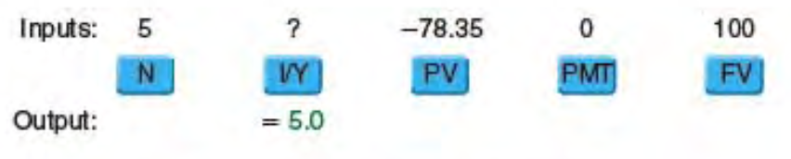
Financial Calculator 1- Interest Rate
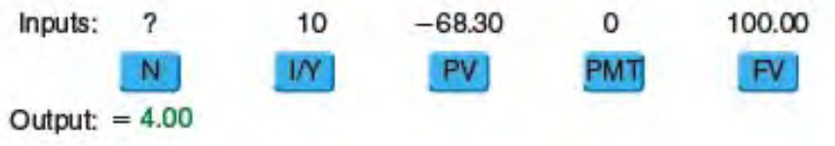
Financial Calculator 2 – Number of periods

Annuity Payments

Annuity: A series of payments of an equal amount at fixed, equal intervals for a specified number of periods.

Ordinary (deferred) annuity: An annuity with payments that occur at the end of each period.

Annuity due: An annuity with payments that occur at the beginning of each period.

To be considered an annuity, the series of cash flows must be constant and occur at equal intervals.

Future Value of an Annuity, FVA

Future Value of an Ordinary Annuity
To solve FVA we must use the PMT (annuity) key.
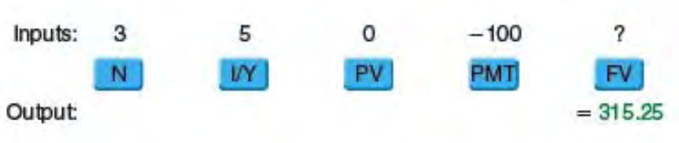
Financial Calculator 3 – Solving for FVA₃

Future Value of Annuity Due, FVA(DUE)
FVA(DUE)_{n}: The future value of annuity due over n periods
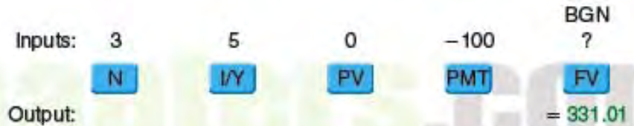
Financial Calculator 4 – FVA(DUE)
Ceteris paribus FVA(DUE)_{n} > FVA_{n}

Present Value of an Annuity, PVA

PVA_{n}: The present value of an ordinary annuity with n payments
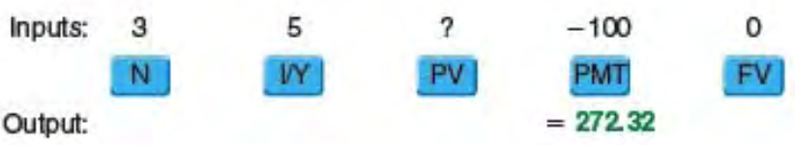
Financial Calculator 5 – Present Value

Present Value of an Annuity Due, PVA(DUE)
PVA(DUE)_{n}: The present value of an annuity due over n periods
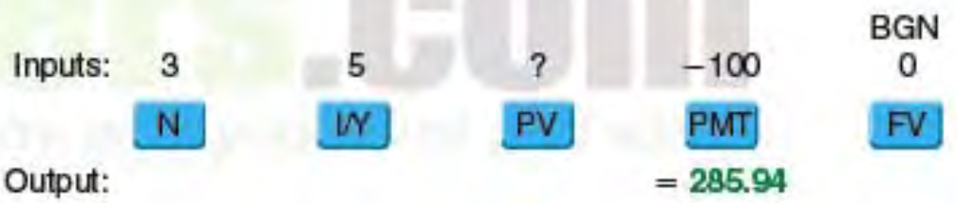
Financial Calculator 6 - PVA(DUE)

Computing Annuity Payments (PMT), Interest Rates (r), and Time (n)

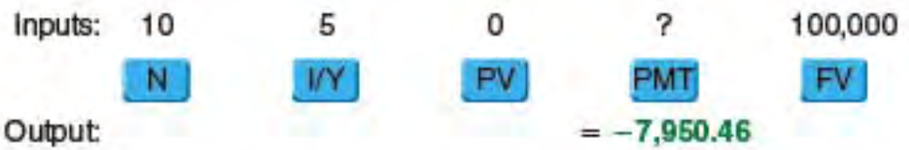
Financial Calculator 7 - Computing Annuity Payments
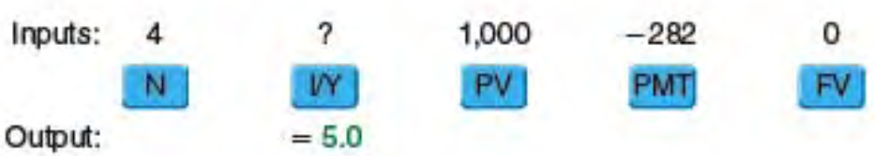
Financial Calculator 8 - Solving for r
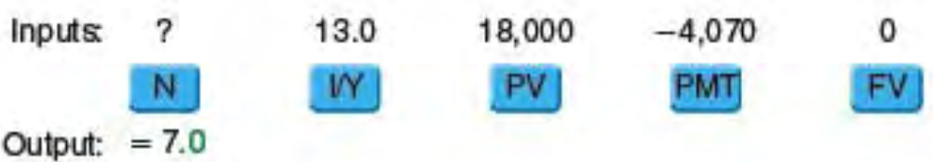
Financial Calculator 9 - Solving for n

Perpetuities

Perpetuity: A setup of equal payments expected to continue forever.

PVP = Payment / Interest Rate = PMT / r

Consol: A perpetual bond issued by the British government to consolidate past debts; in general, any perpetual bond.

Uneven Cash Flow Streams

Uneven cash flow stream: A series of cash flows in which the amount varies from one period to the next.

Payment (PMT): This term designates constant cash flows, that is, the amount of an annuity payment

Cash flow (CF): This term designates cash flows in general, including uneven cash flows.

You can find the present value of any cash flow stream by summing the present values of the individual cash flows.

Financial calculator solution:
- Press CF key.
- CF₀ is initial cash flow
- C01, C02, etc. amount of cash flow
- F01, F02, etc. frequency of cash flow (leave empty unless specified)
- I is interest
- NPV returns Net Present Value (CPT NPV)

Future Value of an Uneven Cash Flow Stream
Terminal value: The future value of a cash flow stream.

Financial calculator solution: Simply input CF values into the cash flow register and then press the IRR key, which stands for Internal Rate of Return.

Semiannual and Other Compounding Periods

Annual compounding: The process of determining the future (or present) value of a cash flow or series of cash flows when interest is paid once per year.

Semiannual compounding: The process of determining the future (or present) value of a cash flow or series of cash flows when interest is paid twice per year.

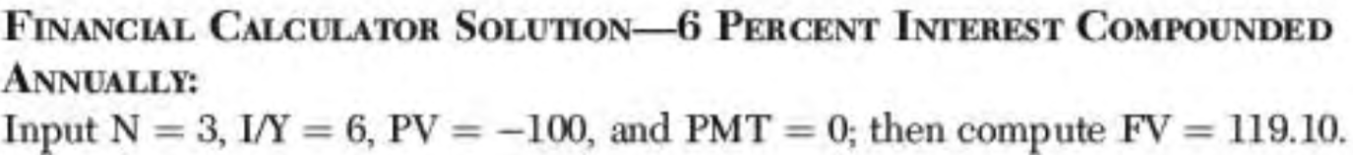
Financial Calculator 10

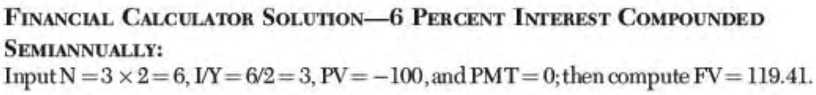
Financial Calculator 11

Comparison of Different Interest Rates

Ceteris paribus, the greater the number of compounding periods per year, the greater the effective rate of return on an investment.
- Simple (quoted) interest rate (r_{SIMPLE}): The rate quoted by borrowers and lenders that is used to determine the rate earned per compounding period (periodic rate, r_{PER})
- Annual percentage rate (APR): Another name for the simple interest rate, r_{SIMPLE}; does not consider the effect of interest compounding, thus making it a noncompounded interest rate
- Effective (equivalent) annual rate (r_{EAR}): The annual rate of interest actually being earned, as opposed to the quoted rate, considering the compounding of interest

Effective annual rate (EAR) = r_{EAR} = (1 + (r_{SIMPLE}/m))^{m} – 1.0 = (1 + r_{PER})^{m} – 1.0

Semiannual compounding (or any non-annual compounding) can be handled:
- State everything on a periodic basis rather than on an annual basis
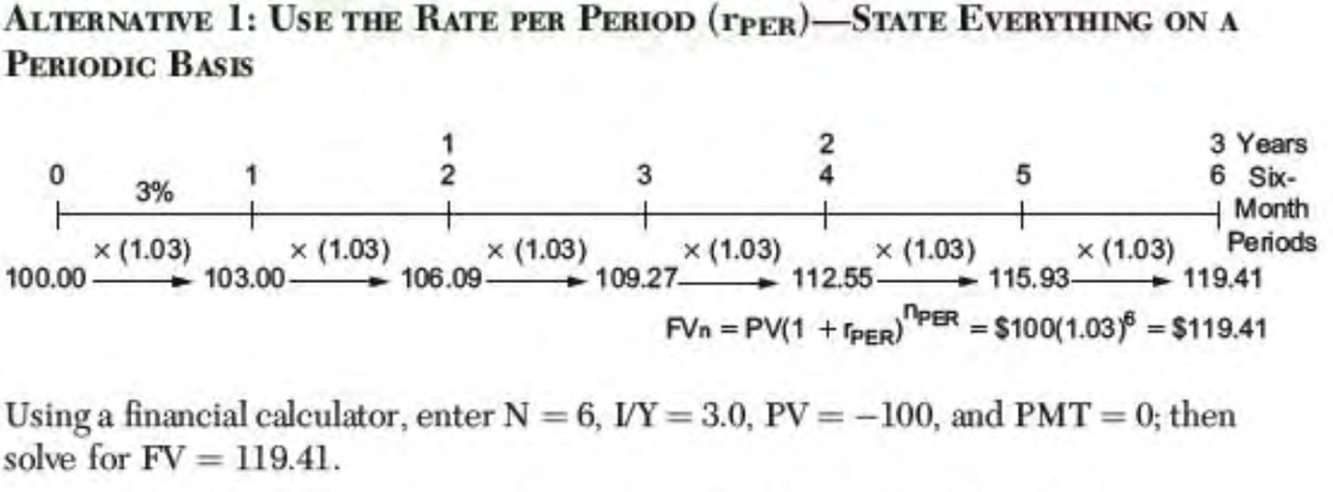
Financial Calculator 12
- Find the effective annual rate (r_{EAR}) by applying above equation
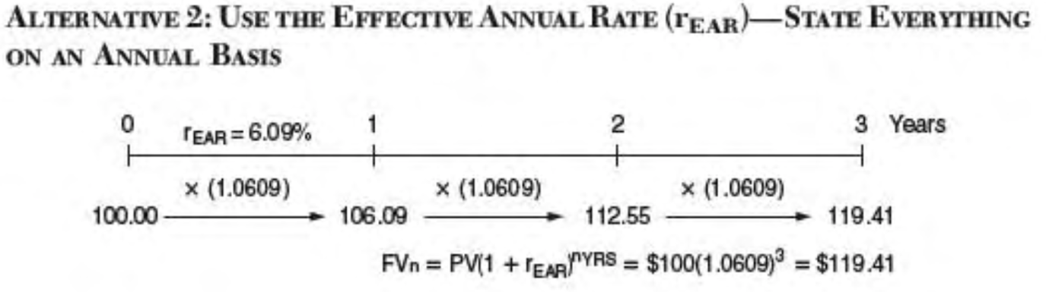
Financial Calculator 13

When computing either the future value or the present value of a lump-sum amount, either:
- Convert the simple annual interest rate (ARP = r_{SIMPLE}) to the periodic interest rate (r_{PER}) and the number of years (n_{YRS}) to the total number of compounding periods (n_{PER}) during the life of the investment (loan) OR
- Convert the ARP to the effective annual rate (r_{EAR}) and use the number of years (n_{YRS})
One of the most important applications of compound interest involves loans that are paid off in installments over time.

Amortized loan: A loan that requires equal payments over its life; the payments include both interest and repayment of the debt.

Amortization schedule: A schedule showing precisely how a loan will be repaid. It gives the required payments on each payment date and a breakdown of the payment, showing how much is interest and how much is repayment principal.

An asset’s value is based on the future cash flows it is expected to produce during its life.

The Cost of Money (Interest Rates)

In a free economy, the excess funds of lenders are allocated to borrowers in the financial markets through a pricing system that is based on the supply of, and the demand for, funds. This system is represented by interest rates, aka the cost of money.

Realized Returns (Yields)

Whether the investment instrument is debt or equity, the $ return earned by an investor can be divided into 2 categories:
- Income paid by the issuer of the financial asset
- The change in value of the financial asset in the financial market (capital gains) over some period

Dollar return = (Dollar income) + (Capital gains)

Capital gains = Ending value – Beginning value

If the financial asset is:
- debt, the income from the investment consists of the interest paid by the borrower
- equity, the income from the investment is the dividend paid by a corporation

To determine an investment’s yield, we state the $ return as a % of the $ amount originally invested.

Yield = (Dollar return / Beginning value)

Dollar return = Dollar income + Capital gains

Factors That Affect the Cost of Money

4 fundamental factors affect the cost of money:
- Production opportunities
  - The return available within an economy from investment in productive assets
- Time preference for consumption
  - The preferences of consumers for current consumption s opposed to saving for future consumption
- Risk
  - In a financial market context, the chance that a financial asset will not earn the return promised
- Inflation
  - The tendency of prices to increase over time

The interest rate paid to savers depends in a basic way on
- The rate of return that producers expect to earn on their invested capital
- Savers’ time preferences for current versus future consumptions
- The riskiness of the loan
- The expected future rate of inflation

Interest Rate Levels

Funds are allocated among borrowers by interest rates: Firms with the most profitable investment opportunities are willing and able to pay the most for capital.

If the demand for funds declines, demand curves will shift to the left. If the supply of funds tightens, the supply curve would shift to the left raising interest rates and lowering the level of borrowing in the economy.

Financial markets are independent. When the economy is expanding, firms need capital, and this demand for capital pushes rates higher. Inflationary pressures are strongest during business booms, which also exert upward pressure on rates. Conditions are reserved during recessions. In these periods, slack business reduces the demand for credit, the rate of inflation falls, and interest rates decline.

The Determinants of Market Interest Rates

In general, the quoted (nominal) interest rate on any security (r), is composed of a risk-free rate of interest plus a premium that reflects the riskiness of the security.

Rate of return = r = Risk-free rate + Risk premium

The interest on debt can be expressed:

Rate of return = r = r_{RF} + RP

RP = DRP + LP + MRP

r = Quoted (nominal) rate of interest on a given security
r_{RF} = Quoted risk-free rate of return
RP = Risk premium
DRP = Default risk premium
LP = Liquidity (marketability) premium
MRP = Maturity risk premium

The nominal (quoted) risk-free rate of interest r_{RF}

Nominal (quoted) risk-free rate, r_{RF}: The rate of interest on a security that is free of all risk; r_{RF} is proxied by the T-bill rate or the T-bond rate and includes an inflation premium. It has 2 components:
The real risk-free rate (r*): The rate of interest that would exist on default-free US Treasury securities if no inflation were expected
  - Changes over time depending on economic conditions, especially:
    - On the rate of return corporations and other borrowers are willing to pay to borrow funds
    - On people’s time preferences for current versus future consumption
  - The minimum rate earned on any security, no matter its risk, must include compensation for the loss of purchasing power that is expected during the life of the investment due to inflation.
    - r_{RF} must include a component for the average inflation that investors expect in the future
  - If the term risk-free rate is used without either real or nominal, people generally mean the quoted (nominal) rate
Inflation Premium (IP): An adjustment for the average inflation that is expected during the life of the investment
- r_{RF} = r* + IP

Default Risk Premium (DRP)
The risk that a borrower will default on a loan also effects the market interest rate of a security. The greater the default risk, the higher the interest rate that lenders demand.

Default risk premium (DRP): The difference between the interest rate on a US Treasury bond and a corporate bond of equal maturity and marketability; compensation for the risk that a corporation will not meet its debt obligations.

Liquidity Premium (LP)
Liquidity is generally defined as the ability to convert an asset into cash on short notice and reasonably capture the amount initially invested.
- Government securities, stocks, and bonds trade in very active and efficient secondary markets, whereas the markets for real estate are much more restrictive.
- It is generally easier to convert an asset into cash at a good price the closer the asset’s life is to its maturity date.
- Financial assets are generally more liquid that real assets, short-term financial assets are generally more liquid that long-term financial assets.

Liquidity Premium (LP): A premium added to the rate on a security if the security cannot be converted to cash on a short notice at a price that is close to the original cost.

Maturity Risk Premium (MRP)
Interest rate risk: The risk of capital losses to which investors are exposed because of changing interest rates

Maturity risk premium (MRP): A premium that reflects interest rate risk; bonds with longer maturities have greater interest rate risk
- MRP appears to vary over time, rising when interest rates are more volatile and uncertain, and falling when interest rates are more stable
- The maturity risk premium on T-bonds with 20 to 30 years to maturity normally is in the range of 1 or 2 %

Reinvestment rate risk: The risk that a decline in interest rates will lead to lower income when bonds mature and funds are reinvested

The Term Structure of Interest Rates

Term structure of interest rates: The relationship between yields and maturities of securities

Yield curve: A graph showing the relationship between yields and maturities of securities

Normal yield curve: An upward-sloping yield curve

Inverted (abnormal) yield curve: A downward-sloping yield curve

Why do Yield Curves Differ?
Interest rates consist of a risk-free return, r_{RF}, which includes the real risk-free return (r*) and an adjustment for expected inflation (IP), and a risk premium that rewards investors for various risks, including default risk (DRP), liquidity risk (LP), and maturity risk (MRP).
Although the real risk-free rate of return (r*) does change at time, it generally is relatively stable from period to period. When interest rates shift to substantially different levels, it’s generally because investors have changed either their expectations concerning future inflation or their attitudes concerning risk.
Inflation expectations represent an important factor in the determination of current interest rates and thus the shape of the yield curve.

r_{TREASURY} = r_{RF} + MRP = (r* + IP) + MRP

- Investors generally prefer to hold short-term securities because they are less sensitive to changes in interest rates and provide greater investment flexibility than longer-term securities.
- Borrowers generally prefer long-term debt because short-term debt exposes them to the risk of having to refinance the debt under adverse conditions.
These 2 sets of preferences imply that under normal conditions, a positive maturity risk premium (MRP) exists, and the MRP increases with years to maturity, causing the yield curve to be upward sloping.

Liquidity preference theory: The theory that, ceteris paribus, lenders prefer to make short-term loans rather than long-term loans; hence, they will lend short-term funds at lower rates than they lend long-term funds.

Expectations theory: The theory that the shape of the yield curve depends on investors’ expectations about future inflation rates.

IP is the average of the rate of inflation that is expected for each year during the life of the bond.

Economists often use the yield curve to form expectations about the future of the economy, with a downward-sloping yield curve suggested the economy will weaken in the future.

When supply/demand conditions in one range of maturities are significantly different than in other maturity ranges, interest rates for bonds in that maturity range are either substantially higher or lower than rates in the maturity ranges on either side. In such cases, the resulting yield curve is not smooth or uniform; rather, there is a hump in the yield curve if rates are higher and a dip if rates are lower. The reason these humps and dips occur is because there are instances when investors and borrowers prefer bonds with specific maturity ranges.

Market segmentation theory: The theory that every borrower and lender has a preferred maturity and that the slope of the yield curve depends on the supply of and the demand for funds in the long-term market relative to the short-term market.

Interest rates on corporate bonds are determined using:

r = r_{RF} + (DRP + LP + MRP)

r_{RF} = (r* + IP)

For corporate bonds, DRP > 0, LP > 0, which means that interest rates on corporate bonds are greater than interest rates on Treasury securities with the same maturities. r_{RF} for both is the same since r_{RF} = r* + IP. RP_{Corporate} > RP_{Treasury}.

Does the Yield Curve Indicate Future Interest Rates?

Significantly more analysis than examining a yield curve is needed to forecast interest rates due to the many factors that affect them.

According to the expectations theory, whenever the annual rate of inflation is expected to decline, the yield curve must be downward sloping (inverted) and vice verse.

Yield on a 2-year bond = (R1 + R2) / 2
R = Interest rate in year x

Other Factors the Influence Interest Rate Levels

Federal Reserve Policy
- The money supply has a major effect on both the level of economic activity and the rate of inflation
- In the US, the Federal Reserve Board controls the money supply.
  - If the Fed wants to control growth in the economy, it slows growth in the money supply. This would cause interest rates to increase and inflation to stabilize. Opposite is true when loosening the money supply.

Open market operation: Operations in which the Fed buys or sells Treasury securities to expand or contract the US money supply
- When the Fed want to increase the money supply, it purchases government securities from primary dealers

Federal Deficits
If the federal government spends more than it takes in from tax revenues, it runs a deficit. Deficit spending must be covered either by borrowing or by printing money.
- If the government borrows, the added demand for funds pushes up interest rates
- If the government prints money, the expectation is that future inflation will increase, also driving up interest rates
- The larger the federal deficit, ceteris paribus, the higher the level of interest rates.

International Business (Foreign Trade Balance)
If citizens of a nation buy more than they sell, that nation is said to be running a foreign trade deficit. When trade deficits occur, they must be financed, and the main source of financing is debt.
The larger the trade deficit, the more a nation must borrow. An increase in borrowing drive up interest rates. Foreigners are willing to hold this nation’s debt only if the interest rate on this debt is competitive with that of other countries.
If the Fed attempts to lowers interest rates in the US, causing US rates to fall below rates abroad, foreigners will sell US bonds, thus depressing bond prices and causes an interest rate increase in the US.
When interest rates increase significantly in the bond markets, investors generally sell their stock and invest the proceeds in bonds.

Business Activity
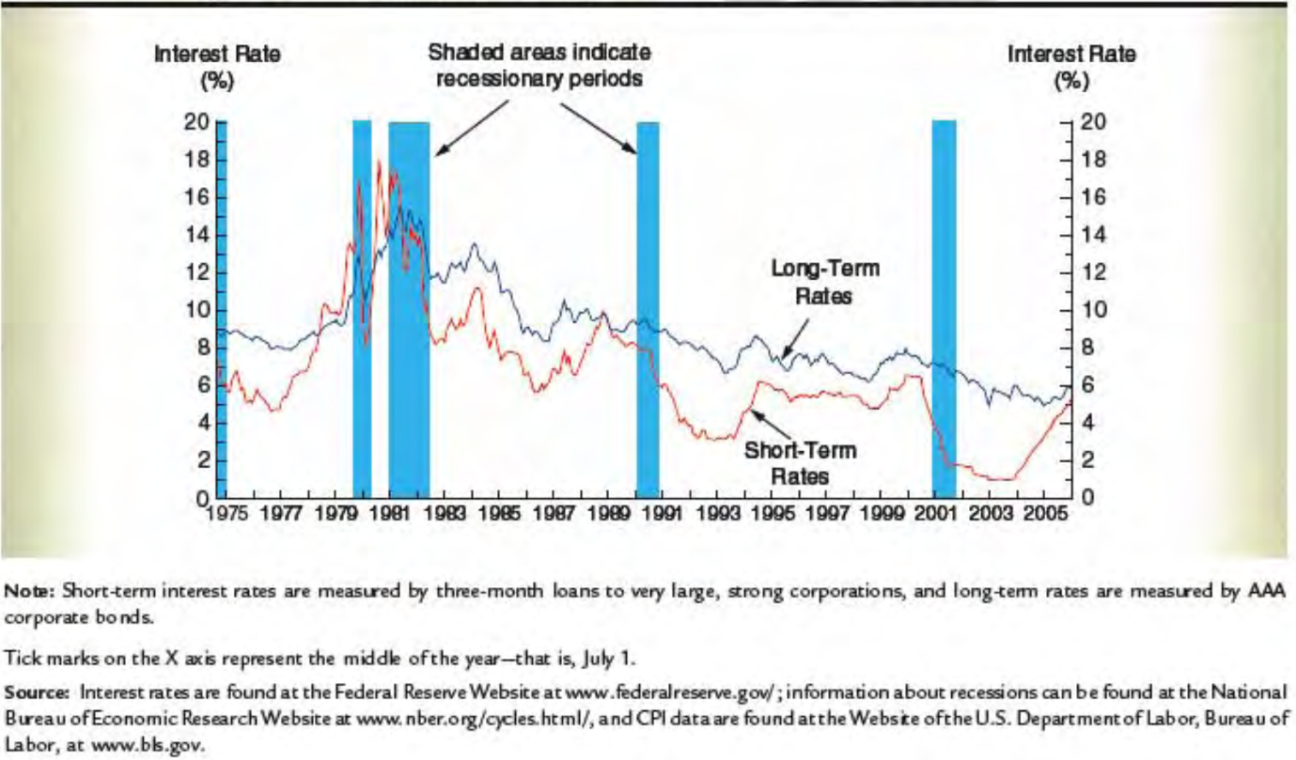
During recessions, both the demand for money and the rate of inflation tend to fall, and, at the same time, the Fed tends to increase the money supply in an effort to stimulate the economy. As a result, interest rates typically decline during recessions

Interest Rate Levels and Stock Prices

Interest rates have 2 effects on corporate profits:
- Because interest is a cost, the higher the rate of interest, the lower the firm’s profits, ceteris paribus.
- Interest rates affect the level of economic activity, and economic activity affects corporate profits. Interest rates obviously affect stock prices because of their effects on profits.
  - The influence stock prices because of competition in the market between stocks and bonds.
  - If interest rates rise sharply, investors can obtain higher returns in the bond market, which induces them to sell stock and transfer funds from the stock market to the bond market.

The Cost of Money as a Determinant of Value

For the most part, the same factors that determine the cost of money also affect other rates of return, including rates earned on stocks and other investments.

The value of an asset is a function of the cash flows it is expected to generate in the future and the rate of return at which investors are willing to provide funds to purchase the investment.

The value of an asset can be stated in simple mathematical terms as the present value of the future cash flows that the asset is expected to generate during its life.
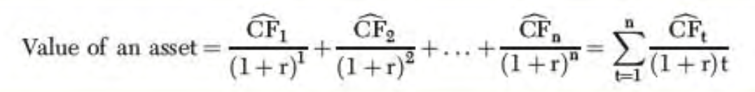
… 1 r represents the cost of funds
In general, when the cost of money increases the value of an asset decreases. When rates in the financial markets increase, the prices (values) of financial assets decrease.

Bonds (Debt) – Characteristics and Valuation

Debt Characteristics

Debt: a loan to a firm, government, or individual.

Principal Value, Face Value, Maturity Value, and Par Value
The principal value of a debt represents the amount owed to the lender. For debt issued by corporations, the principal amount is repaid at maturity, thus the principal value is also called the maturity value. And since the principal value is written on the face, or outside page, of the debt instrument, it is also called the face value. When the market value of debt is the same as its face value, it is said to be selling at par, thus the principal amount is also referred to as the par value.

Interest Payments
Discounted securities: Securities selling for less than par value.

Maturity Date
The maturity date represents the date on which the principal amount of a debt is due. Installment loans require the principal amount to be repaid in several payments during the life of the loan.

Priority to Assets and Earnings
Corporate debt holders have priority over stockholders with regard to distribution of earnings and liquidation of assets. Interest on debt is paid before stock dividends are distributed, and any outstanding debt must be repaid before stockholders can receive any proceeds from liquidation of the company.

Control of the Firm (Voting Rights)
Corporate debt holders do not have voting rights, however, debt holders can affect the management and the operations of a firm by placing restrictions on the use of the funds as part of the loan agreement.

Types of Debt

Short-Term Debt
Short-term debt generally refers to debt instruments with maturities of one year or less.
- Treasury bills (T-bills): Discounted short-term debt instruments issued by the US government.
  - Prices are determined by an auction process
- Repurchase Agreement (Repo): An arrangement in which one firm sells some of its financial assets to another firm with a promise to repurchase the securities at a later date
  - Some repos last for days or even weeks, though the maturity for most is overnight
- Federal Funds: Overnight loans from one bank to another
  - The interest associated with such debt is known as the federal funds rate.
  - Have very short maturities, often overnight.
- Banker’s Acceptance: An instrument issued by a bank that obligates the bank to pay a specified amount at some future date
  - Best described as a postdated check
  - Generally sold by the original owner before its maturity to raise immediate cash
  - Does not pay interest
  - Sold at a discount
  - Generally, have maturities of 180 days or less
- Commercial Paper: A discounted instrument that is a type of promissory note, or legal IOU, issued by large, financially sound firms
  - Does not pay interest
  - Sold at discount
  - Maturity varies from 1 – 9 months, average is 5 months
  - Sold primarily to other businesses, insurance companies, pension funds, money market mutual funds, and banks
- Certificate of Deposit: An interest-earning time deposit at a bank or other financial intermediary
  - Earn periodic interest
  - Must be kept at the issuing institution for a specified time period
  - To liquidate prior to maturity, the owner must return it to the issuing institution, which applies an interest penalty to the amount paid
  - Negotiable CD: Certificate of deposit that can be traded to other investors prior to maturity; redemption is made by the investor who owns the CD at maturity
    - Often called jumbo CD
- Eurodollar Deposit: A deposit in a foreign bank that is denominated in US dollars
  - Not exposed to exchange rate risk
- Money Market Mutual Funds: Pools of funds managed by investment companies that are primarily invested in short-term financial assets

Long-Term Debt
Long-term debt refers to debt instruments with maturities greater than one year.
- Term Loans: A loan, generally obtained from a bank or insurance company, on which the borrower agrees to make a series of payments consisting of interest and principal
  - Usually negotiated directly between the borrowing firm and a financial institution
  - Often referred to as private debt
  - Maturities vary from 2 to 30 years, most are between 3 and 15 years
  - Have 3 major advantages over public debt offerings
    - Speed
    - Flexibility
    - Issuance Cost
  - Because they are negotiated directly between the lender and the borrower, formal documentation is minimized
  - Key provisions can be worked out much quicker
  - Not necessary for loan to go through SEC
  - Interest rates can be either fixed for the life of the loan or variable
    - If fixed it will be set close tot the rate on bonds of equivalent maturity and risk at the time of issue
    - If variable it will be set at a certain number of percentage points above an index representing the prime rate, the commercial paper rate, the T-bill rate, or some other designated rate
- Bonds: A long-term debt instrument under which a borrower agrees to make payments of interest and principal on specific dates to the investor.
  - Coupon rate: Interest paid on a bond or other debt instrument stated as a percentage of its face, or maturity, value
  - Some of the more common bonds issued are:
    - Government bonds: Debt issued by federal, state, or local governments
      - US government bonds are issued by the US Treasury and are called either Treasury notes or Treasure bonds. Both types of debt pay interest semiannually. The primary difference between the two is the maturity when the debt is issued: the original maturity on notes is from more than 1 year to 10, whereas the original maturity on bonds exceeds 10 years.
      - Municipal bond: A bond issued by state or local governments
      - Revenue bond: A municipal bond that generates revenue, which in turn can be used to make interest payments and replay the principal
      - General obligation bond: A municipal bond backed by the local government’s ability to impose taxes
    - Corporate bonds: Long-term debt instruments issued by corporations
      - Resemble term loans, but a bond issue generally is advertised, offered to the public, and sold to many different investors
    - Mortgage bonds: A bond backed by fixed assets. First mortgage bonds are senior in priority to claims of second mortgage bonds
      - Second mortgages are sometimes called junior mortgages
    - Debenture: A long-term bond that is not secured by a mortgage on specific property
      - Subordinated debenture: A bond that has a claim on assets only after the senior debt has been paid off in the event of liquidation
    - Income bond: A bond that pays interest to the holder only if the interest is earned by the firm
      - Putable bond: A bond that can be redeemed at the bondholder’s option when certain circumstances exist
      - Indexed (purchasing power) bond: A bond that has interest payments based on an inflation index to protect the holder from inflation
      - Floating-rate bond: A bond whose interest rate fluctuates with shift in the general level of interest rates
    - Zero coupon bond: A bond that pays no annual interest but is sold at a discount below par, thus providing compensation to investors in the form of capital appreciation
    - Junk bond: A high-risk, high-yield bond used to finance mergers, leveraged buyouts, and troubled companies

Rates of Return on Different Types of Debt
Because short-term debt has greater liquidity and less maturity risk than long-term debt, ceteris paribus, we expect the rates on short-term debt to be lower than the rates on long-term debt.

Bond Contract Features

Bond Indenture
Indenture: A formal agreement between the issuer of a bond and the bondholders.

Trustee: An official who ensures that the bondholders’ interests are protected and that the terms of the indenture are carried out.

Restrictive covenant: A provision in a debt contract that constrains the actions of the borrower.

Call Provision
Call provision: A provision in a bond contract that gives the issuer the right to redeem the bonds under specified terms prior to the normal maturity date. Call protection refers to bonds that are not callable (deferred calls) until several years after they are issued.

Sinking Fund
Sinking fund: A required annual payment designed to amortize a bond issue.
Failure to meet the sinking fund requirement will throw the bond issue into default. A firm can handle the sinking fun in 2 ways: 1) randomly calling for redemption at par value of a certain % of the bonds each year or 2) by purchasing the required amount of bonds in the open market.

Convertible Feature
Conversion feature: Permits bondholders to exchange their investments for a fixed number of shares of common stock.
The conversion ratio is defined as the number of shares of stock that the bondholder receives upon conversion.

Bond Ratings

Investment-grade bond: A bond rated A or triple B; many banks and other institutional investors are permitted by law to hold only bonds rated investment-grade or better.

Bond Rating Criteria
Bond ratings are based on both qualitative and quantitative factors. Factors considered by the bond rating agencies include the financial strength of the company as measured by various ratios, collateral provisions, seniority of the debt, restrictive covenants, provisions such as a sinking fund or a deferred call, litigation possibilities, regulation, etc. No precise formula is used to set a rating, all factors plus others are taken into account, but not in a mathematically precise manner.

Importance of Bond Ratings
Bond ratings are important to both issuers and investors.
- Because a bond’s rating serves as an indicator of its default risk, the rating has a direct measurable influence on the bond’s interest rate and firm’s cost of using such debt
- Most bonds are purchased by institutional investors rather than individuals, and many institutions are restricted to investment-grade securities

Foreign Debt Instruments

Any debt sold outside the country of the issuer is called international debt.

Foreign debt: Debt issued by a foreign borrower but denominated in the currency of the country in which it is sold.

Eurodebt: Debt issued in a country other than the one in whose currency the debt is denominated.

Eurobonds appeal to investors for several reasons:
- They are issued in bearer form rather than as registered bonds, so names and nationalities of investor are not recorded.
- Most governments do not withhold taxes on interest payments associated with Eurobonds.

Other type of Eurodebt includes:
- Eurocredits: Bank loans that are denominated in the currency of a country other than that in which the lending bank is located.
  - LIBOR: The London Interbank Offer Rate; the interest rate offered by the best London banks on deposits of other large, very creditworthy banks.
- Euro-commercial paper (Euro-CP): Similar to commercial paper issued in the US. This short-term debt instrument is issued by corporations, and it typically has a maturity of 1, 3, or 6 months.
- Euronotes: Represent medium-term debt, typically have maturities ranging from 1 to 10 years. Closely resemble longer-term debt instruments such as bonds.

Valuation of Bonds

A bond’s market price is determined by the cash flows that it generates, both the interest that it pays, which depends on the coupon interest rate, and the principal amount that must be repaid. The higher the coupon rate, the higher the market price of the bond.

New issue: A bond that has just been issued.
Seasoned issue: Once the bond has been on the market for a while.

The Basic Bond Valuation Model
The value of any financial asset is based on the cash flows that investors expect the asset to generate in the future. In the case of a bond, the cash flows consist of interest payments during the life of the bond plus a return of the principal amount borrower when the bond matures.

r_{d} = Average rate of return investors require to invest in the bond (d = debt)
N = Number of ears before the bond matures
INT = Dollars of interest paid each year = Coupon rate x par value
M = Par, or face, value of the bond

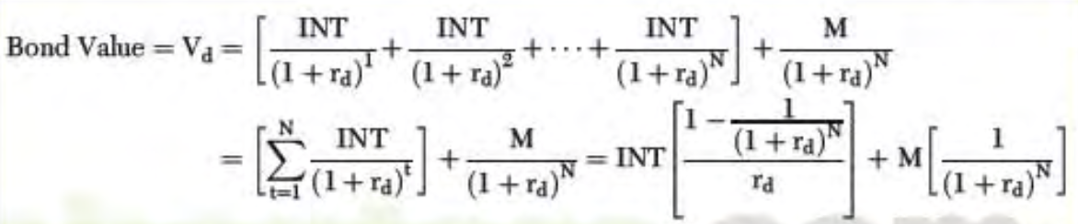
Equation 1 lol… or just use a financial calculator
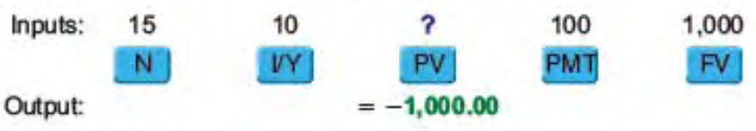
Financial Calculator 14 rd=10%, n=15, int=$100, m=$1000

Finding Bond Yields (Market Rates): Yield to Maturity and Yield to Call

Yield to Maturity
Yield to maturity (YTM): The average rate of return earned on a bond if it is held to maturity.
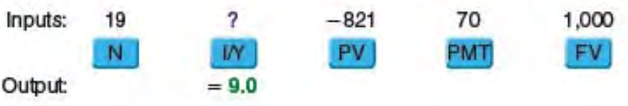
Financial Calculator 15

Yield to Call
Yield to call (YTC): The average rate of return earned on a bond if it is held until the first call date.
Call price: The price a firm hast to pay to recall a bond; generally equal to the principal amount plus some interest
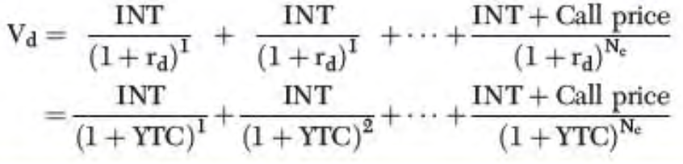
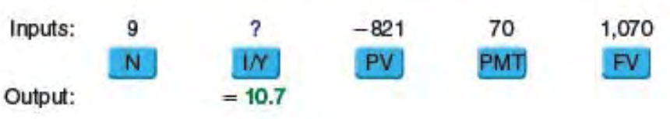
Financial Calculator 16

Interest Rates and Bond Values

When the market yield (YTM) and the coupon rate of interest are equal, the bond sells for its par value; when the market yield is greater than the coupon rate of interest, the bond sells for less than its par value (discount), and when the market yield is less than the coupon rate of interest, the bond sells for greater than its par value (premium).

Discount bond: A bond that sells below its par value. This occurs whenever the going rate of interest rises above the coupon rate.

Premium bond: A bond that sells above its par value. This occurs whenever the going rate of interest falls below the coupon rate.

When interest rates change, the values of bonds change in an opposite direction.

Changes in Bond Values over Time

The percentage rate of return earned on a bond consists of an interest (current) yield plus a capital gains yield.

Interest (current) yield = Interest payment / market price of the bond

Capital gains yield = % change in the market price of a bond over some period of time.

Bond yield = Current (interest) yield + Capital gains yield

Equation 2 V_{dbegin} represents the value of the bond at the beginning of the period, v_{dend} at the end of the period
Regardless of what interest rates do in the future, the bond’s price will approach its face value as it nears its maturity date
- Whenever the going rate of interest, r_{d}, equals the coupon rate, a bond will sell at its par value.
- Interest rates change over time, but the coupon rate remains fixed after the bond has been issued. Whenever the going rate of interest is greater than the coupon rate, a bond’s price will fall below its par value (a discount bond); whenever the going rate of interest is less than the coupon rate, a bond’s price will rise above its par value (a premium bond).
- An increase in interest rates will cause the price of an outstanding bond to fall, whereas a decrease in rates will cause it to rise.
- The market value of a bond will always approach its par value as its maturity date approaches, provided the firm doesn’t go bankrupt.

Bond Values with Semiannual Compounding

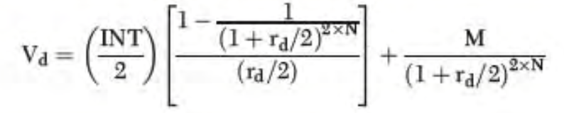
… 2 modified bond equation to evaluate semiannual payment bonds

Interest Rate Risk on a Bond

Changes in interest rates affect bondholder in 2 ways:
- An increase in interest rates leads to a decline in the values of outstanding bonds.
  - Interest rate price risk: The risk of changes in bond prices to which investors are exposed due to changing interest rates
- Many bondholders reinvest the cash flows. If interest decline, the bondholders will earn a lower rate of return on reinvested cash flows, which will reduce the future value of their portfolios.
  - Interest rate reinvestment risk: The risk that income from a bond portfolio will vary because cash flows must be reinvested at current market rates.

The longer the maturity of the bond, the more significantly its price changes in response to a given change in interest rates.

Stocks (Equity) – Characteristics and Valuation

Preferred Stock

Preferred (hybrid) stock is similar to bonds (debt) in some respects and similar to common stock in other respects.
- Like bonds, preferred stock has a par (face) value.
- Preferred dividends are similar to interest payments in that they are fixed in amount and must be paid before common stock dividends can be distributed. If the preferred dividend is not earned, directors can omit (pass) it without throwing the company into bankruptcy.
- Although preferred stock has a fixed payment like bonds, a failure to make this payment will not lead to bankruptcy.
- Financial analysts treat preferred stock as either debt or as equity.

Preferred stock has a number of features:
Par Value
  - Most preferred stock has a par value or its equivalent. Par value is important for 2 reasons:
    - It establishes the amount due to the preferred stockholders in the event of liquidations
    - The preferred dividend generally is states as a % of the par value
Cumulative Dividends: A protective feature on preferred stock that requires preferred dividends previously not paid to be disbursed before any common stock dividends can be paid
  - Dividends in arrears: Holders of this stock are ensured they will be paid any missed preferred dividend payments before common stockholders are paid any new dividends
Maturity
  - Preferred stock generally has no specific maturity date
  - Firms can essentially incorporate a maturity provision by including a call provision with the preferred stock issue
Priority to Assets and Earnings
  - Preferred stockholders have priority over common stockholders with regard to earnings and assets
Control of the Firm (Voting Rights)
  - Almost all preferred stock is nonvoting stock, however, preferred stockholders often are given the right to vote for directors if the company has not paid the preferred dividend for a specified period.
Convertibility
  - Most preferred stock that has been issued in recent years is convertible into common stock
  - Conversion price: A convertible stock’s principal amount per share divided by the conversion ratio
Other Provisions
  - A call provision gives the issuing corporation the right to call in the preferred stock for redemption
    - Call premium: The amount in excess of par value that a company must pay when it calls a security
  - Sinking funds call for the repurchase and retirement of a given % of the preferred stock each year
  - Participating is a rare type of preferred stock that participates with common stock in sharing the firm’s earnings

Common Stock

Common stockholders are entitled to any earnings that remain after interest payments are made to bondholders and dividends are paid to preferred stockholders. Because debt and preferred stock are generally fixed-payment securities, common stockholders don’t have to share earnings that exceed the amounts that the firm is required to pay to bondholders and preferred stockholders.

Par Value
Common stock does not have par value.
- Corporations that are chartered in certain states are required to assign par values to their common stocks
- Legally, the par value of a common stock represents a stockholder’s minimum financial obligation in the event the corporation is liquidated and its debts are repaid
- The par value and market value of a common stock are not related
- Par value does not determine market value, and vice versa

Dividends
The firm has no obligation, contractual or implied, to pay common stock dividends.
- The return that investors received when they own a company’s common stock is based on both the change in the stock’s market value (capital gain) and the dividend paid by the company
- Income stocks: Stocks of firms that traditionally pay large, relatively constant dividends each year
- Growth stocks: Stocks that generally pay little or no dividends so as to retain earnings to help fund growth opportunities

Maturity
Common stock has no specified maturity, it is perpetual.
- However, at times companies repurchase shares of the common stock. Stock repurchases might be undertaken when:
  - The firm has excess cash but no good investment opportunities
  - The price of the firm’s stock is undervalued
  - Management wants to gain more ownership control of the firm

Priority to Assets and Earnings
Common stockholders can be paid dividends only after the interest on debt and the preferred dividends are paid. In the event of liquidation resulting from bankruptcy, common stockholders are last to receive any funds.

Control of the Firm (Voting Rights)
Common stockholders have the right to elect the firm’s directors, who appoint the officers who manage the business. Stockholders also vote on:
- Shareholder’s proposals
- Mergers
- Changes in the firm’s charter
In small firms the major stockholder typically assumes the position of president and chairperson of the board of directors. Stockholders can remove the managers of most large, publicly owned firms if they decide that a management team is not effective.
Corporations must hold an election of directors periodically, usually once a year, with the vote taken at the annual meeting.
- Each share of stock normally has one vote
- Proxy: A document giving one person the authority to act for another, typically the power to vote shares of common stock
  - Management of large firms always solicits, and usually gets, stockholders’ proxies
- Proxy fight: An attempt by a person or group of people to gain control of a firm by getting its stockholders to grant that person or group the authority to vote their shares so as to change the management team
- Takeover: An action whereby a person or group succeeds in ousting a firm’s management and taking control of the company

Preemptive right: A provision in the corporate charter or bylaws that gives existing common stockholders the right to purchase on a pro rata basis new issues of common stock.
- Requires a firm to offer existing stockholders shares of a new stock issue in proportion to their ownership holdings before such shares can be offered to other investors
- The purpose of the preemptive right is it:
  - Protects the power of control of current stockholders
  - Protects stockholders against the dilutions of value that would occur if new shares were sold at relatively low prices

Types of Common Stock
- Classified stock: Common stock that is given a special designation, such as Class A, to meet special needs of the company
- Founders’ shares: Stock owned by the firm’s founders that has solve voting rights but generally pays out only restricted dividends for a specified number of years
- Closely help corporations: A corporation that is owned by a few individuals who are typically associated with the firm’s management
- Publicly owned corporations: A corporation that is owned by a relatively large number of individuals who are not actively involved in its management

Equity Instruments in International Markets

American Depository Receipts (ADRs): Certificates created by organizations such as banks that represent ownership in stocks of foreign companies that are held in trust by a bank located in the country in which the stock is traded.
- Each ADR certificate represents a certain number of shares of stock of a foreign company, entitling the owner to receive any dividends paid by the company is US$
- The market values of ADRs move in tandem with the market values of the underlying stocks that are held in trust

Foreign Equity (Stock)
Euro stock: Stock traded in countries other than the home country of the company, not including the US.
Yankee stock: Stock issued by foreign companies and traded in the US.

Stock Valuation – Dividend Discount Model (DDM)

Definitions of Terms Used in the Stock Valuation Models
A stock’s value is found in the same manner as the values of other assets, that is, the present value of the expected future cash flow stream. A stock’s expected cash flow consists of 2 elements:
- The dividends expected in each year
- The price that investors expect to receive when they sell the stock back
- Expected dividend =_{t}: The dividend that the stock is expected to pay at the end of Year t
- Market price (value) = P_{o}: of the stock today
- Intrinsic value =_{o}: The value of an asset that, in the mind of a particular investor, is justified by the facts; can be different from the asset’s current market price, its book value, or both
- growth rate = g: The expected rate of change in dividends per share
- required rate of return = r_{s}: The minimum rate of return on a common stock that stockholders consider acceptable
- Dividend yield =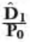: The expected dividend divided by the current price of a share of stock
- Capital gains yield =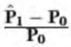: The change in price (capital gain) during a given year divided by the price at the beginning of the year
- Expected rate of return = _{s}: The rate of return on a common stock that an individual stockholder expects to receive. It is equal to the expected dividend yield plus the expected capital gains yield.
  - 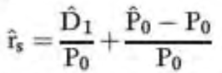
- Actual (realized) rate of return = : The rate of return on a common stock actually received by stockholders; can be greater than or less than _{s} and/or r_{s}

Expected Dividends as the Basis for Stock Values
To compute the value of the stock:
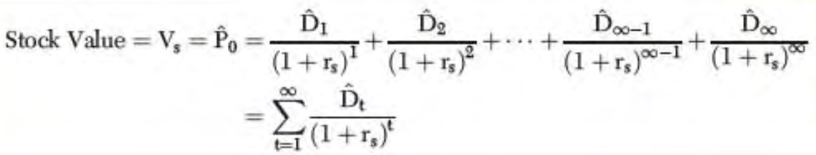
Equation 3
The value of the stock is still determined by this equation, unless the company is likely to be liquidated.

The value of a share of stock must equal the present value of the dividend stream that the company is expected to pay throughout its life

Valuing Stock with Zero Growth
Zero growth stock: A common stock whose future dividends are not expected to grow at all
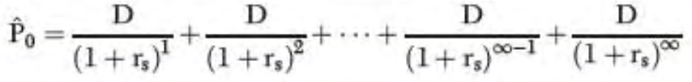
Equation 4
A zero growth stock is a perpetuity. The value of any perpetuity is simply the cash payment divided by the discount rate.
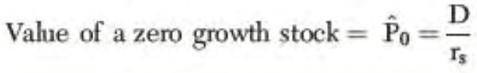
Equation 5 Value of a zero growth stock
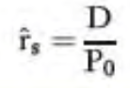
Equation 6 For a stock with constant $ dividends. ˆis put on the r value because it is an expected rate of return

Valuing Stocks with Constant (Normal) Growth
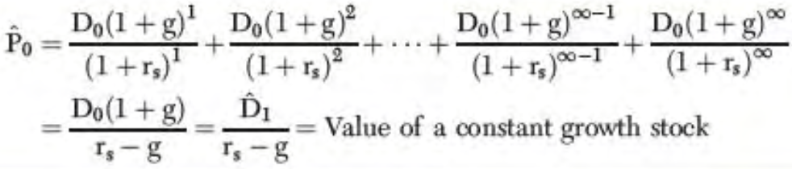
Equation 7 Value of a constant growth stock
Constant growth model: Also called the Gordon model, it is used to find the value of a stock that is expected to experience constant growth.
- If we summed the present values of each future dividend it would equal the value of the stock, _{o}.
- Growth in dividends occurs primarily as a result of EPS.
- Earnings growth results for a number of factors, including inflation, amount of earnings the company retains and reinvests, and ROE.
- If output (in units) remains stable and if both sales prices and input costs rise at the inflation rate, then EPS will also grow at the inflation rate.
- EPS will grow as a result of the reinvestment (plowback) of earnings.

Expected Rate of Return on a Constant Growth Stock
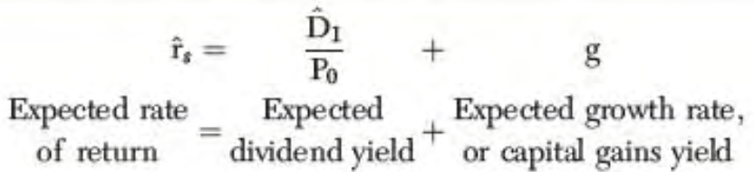
Equation 8
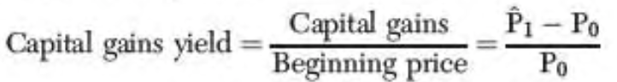
Equation 9
For a constant growth stock, the following conditions must hold:
- The dividend is expected to grow forever at a constant rate
- The expected dividend yield is constant
- The expected total rate of return, _{s}, is equal to the expected dividend yield plus the expected growth rate 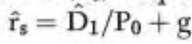

Valuing Stocks with Nonconstant Growth
Nonconstant growth: The part of the life cycle of a firm in which its growth either is much faster (supernormal) or is much slower than that of the economy as a whole.

To find the value of any nonconstant growth stock when the growth rate will eventually stabilize:
- Compute the value of the dividends that are affected by nonconstant growth, and then find the present value of these dividends.
- Find the price of the stock at the end of the nonconstant growth period, at which point it becomes a constant growth stock
  - 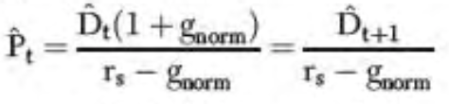
  - 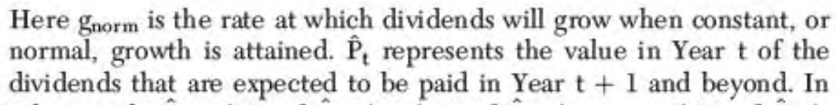
- Add these two present value components to find the intrinsic value of the stock, _{o}. Thus, _{o} = (PV of nonconstant growth dividends) + (PV of _{t})
  - r_{s} = Stockholder’s required rate of return
  - n_{super} = Number of years of supernormal growth
  - g_{super} = Rate of growth in both earnings and dividends during the supernormal growth period
  - g_{norm} = Rate of normal (constant) growth after the supernormal period
  - D₀ = Last dividend paid by the company

Other Stock Valuation Methods

Valuation Using P/E Ratios
P/E ratio: The current market price of the stock divided by the EPS; P₀ / EPS₀
- The P/E ratio gives an indication of the stock’s payback period.
- General indication on whether stock price is high or low, if value is appropriate multiple that value with the firm’s EPS to estimate the appropriate stock price
- P/E ratios are higher (lower) for firms with higher (lower) expected earnings growth and lower (higher) expected required rates of return.

Evaluating Stocks Using the Economic Value Added Approach
Economic value added (EVA): An analytical method that seeks to evaluate the earnings generated by a firm to determine whether they are sufficient to compensate the suppliers of funds, both the bondholders and the stockholders.
- Based on the concept that the earnings from actions taken by a company must be sufficient to compensate the suppliers of funds
- Using the EVA formula, we adjust a firm’s earnings from operations to account for the costs associated with both the debt and the equity issued by the firm

Equation 10 EVA
T = Marginal tax rate, invested capital is the amount of funds provided by investors (debt & equity), percent cost of funds is the average interest rate the firm pays for its invested capital.

To estimate % cost of funds compute:
- The ratio of interest expenses to total debt, giving an indication of the average interest rate the company is paying
- The average return stockholders have earned during the past few years, used as the required rate of return demanded by stockholders
- Next compute the weighted average of these 2 values, using the proportion of the firm that is financed with debt as the weight for the cost of debt and the proportion of the firm that is financed with equity as the weight for the cost of equity
Equation 11 Cost of Funds
Cost of debt is computed on an after-tax basis because interest is tax deductible to the firm; this adjustment is not made to the cost of stock because dividends are not tax deductible.

Maximum dividend per share = EVA / # outstanding shares

Changes in Stock Prices

Changes in stock prices occur for 2 reasons:
- Investors change the rates of return required to invest in stocks
- Expectations about the cash flows associated with stocks change

Stock prices move opposite changes in rates of return, but they move in the same direction as changes in cash flows expected from the stock in the future.
- If investors demand higher (lower) returns to invest in stocks, then prices should fall (increase)
- If investors expect their investments to generate lower (higher) future cash flows, then prices should also fall (increase)

Ceteris paribus:
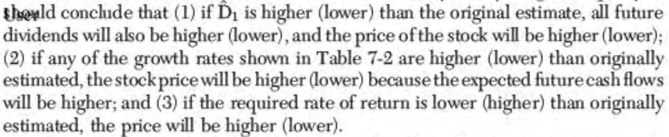
… 3
When a stock price is in equilibrium we should see that the actual price equals the expected price of the stock.

We generally do not know the true equilibrium price of a stock because it is unlikely that
- The company’s future growth pattern is exactly as analysts forecast
- All the assumptions of the model that is used to estimate the equilibrium value are met

Risk and Rates of Return

Each investment is associated with 2 types of risk:
- Diversifiable risk
- Nondiversifiable risk

Defining and Measuring Risk

Risk refers to the chance that some unfavorable event will occur.

Risk occurs any time we cannot be certain about the outcome of a particular activity or event. Risk results from the fact that an action such as investing can produce more than one outcome in the future.

Risk: The chance that an outcome other than the expected one will occur.

The greater the variability of the possible outcomes, the riskier the investment.

Probability Distributions
An event’s probability is defined as the chance that the event will occur.

Probability distribution: A listing of all possible outcomes with a probability assigned to each outcome.

Rates of return = dividend yield + capital gains yield

Expected Rate of Return

Expected value (return), : The rate of return expected to be realized from an investment; the mean value of the probability distribution of possible results.
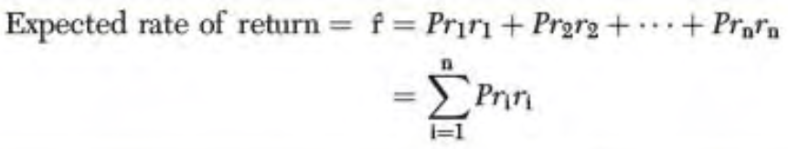
Equation 12 Pr₁ is the probability that the ith outcome will occur, and n is the number of possible outcomes
The expected rate of return represents the average payoff that investors will receive if the probability distribution doesn’t change over a long period of time.

Continuous versus Discrete Probability Distributions
Discrete probability distribution: The number of possible outcomes is limited, or finite.
Continuous probability distribution: The number of possible outcomes is unlimited, or infinite.

The higher the probability distribution, the less variability there is and the more likely it is that the actual outcome will approach the expected value.

The tighter the probability distribution, the lower the risk assigned to a stock.

Measuring Total (Stand-Alone) Risk: The Standard Deviation
Standard deviation, σ: A measure of the tightness, or variability, of a set of outcomes
- Calculate the expected rate of return
- Subtract the expected rate of return from each possible outcome to obtain a set of deviations: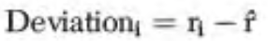
- Square each deviation, multiply the result by the probability occurrence for its related outcome and then sum these products to obtain the variance.
  - Variance, σ²: The standard deviation squared; a measure of the width of a probability distribution
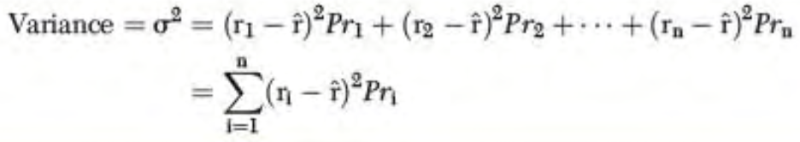
- Take the square root of the variance to get the standard deviation
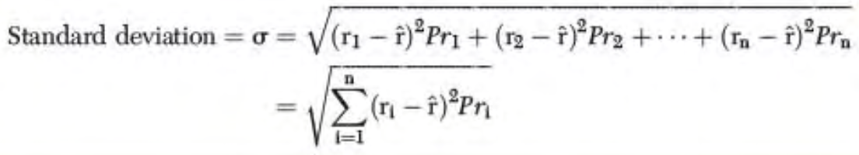

The estimated standard deviation can be computed using a series of past (observed) returns:
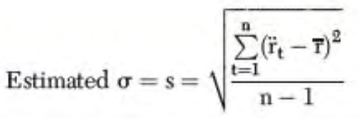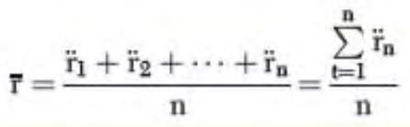
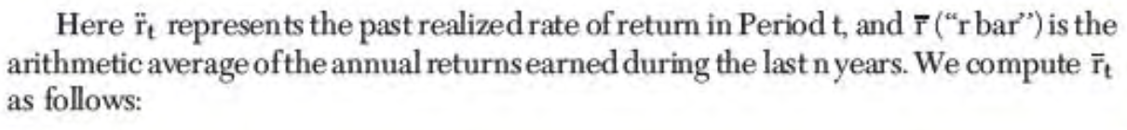

The historical standard deviation is often used as an estimate of the future standard deviation.

Coefficient of Variation (Risk/Return Ratio)
Coefficient of variation (CV): A standardized measure of the risk per unit of return. It is calculated by dividing the standard deviation by the expected return.

CV = Risk / Return =

The coefficient of variation shows the risk per unit of return.
If two companies have the same expected return, it is not necessary to compute the coefficient of variation to compare the 2 investments.

The coefficient of variation is more useful when compared investments have different expected rates of return and different levels of risk.

Risk Aversion and Required Returns
Expected rate of return = (Expected ending value – Beginning value)/Beginning value

Risk aversion: Risk-averse investors require higher rates of return to invest in higher-risk securities.

Risk premium (RP): The portion of the expected return that can be attributed to the additional risk of an investment. It is the difference between the expected rate of return on a given risky asset and the expected rate of return on a less risky asset.

In a market dominated by risk-averse investors, riskier securities must have higher expected returns, than less risky securities.

Portfolio Risk – Holding Combinations of Assets

The risk and return characteristics of an investment should not be evaluated in isolation; instead, the risk and return of an individual security should be analyzed in terms of how that security affects the risk and return of the portfolio in which it is held.

Portfolio Returns
Expected return on a portfolio,_{p}: The weighted average expected return on stocks held in a portfolio.
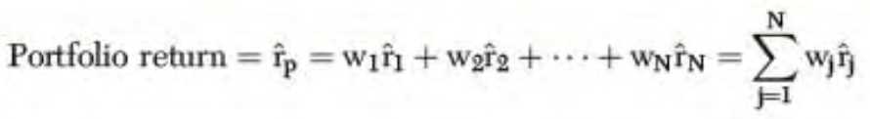
Equation 13
Realized rate of return, : The return that is actually earned. The actual return usually differs frm the expected return.

Portfolio Risk
The expected return of a portfolio is simply a weighted average of the expected returns of the individual stocks in the portfolio. The riskiness of a portfolio generally is not a weighted average of the standard deviations of the individual securities in the portfolio. The portfolio’s risk usually is smaller than the weighted average of the individual stocks’ standard deviations.

Correlation coefficient, p: A measure of the degree of relationship between two variables.

Risk is not reduced if the portfolio contains perfectly positively correlated stocks. In reality most stocks are positively correlated, but not perfectly so. Under such conditions, combining stocks into portfolios reduces risk but does not eliminate it completely.

As a rule, the riskiness of a portfolio will be reduced as the number of stocks in the portfolio increases. The smaller the positive correlation among stocks included in a portfolio, the lower its total risk. In the typical case, in which the correlations among the individual stocks are positive but less than +1.0, some, but not all, risk can be eliminated.

To minimize risk, portfolios should be diversified across industries.

Firm-Specific Risk versus Market Risk
The standard deviation of a one-stock portfolio (average stock) ≈ 28%. A portfolio consisting of all of the stocks in the market (market portfolio) would have a standard deviation of ≈ 15%. Almost ½ the riskiness inherent in an average individual stock can be eliminated if the stock is held as part of a reasonably well-diversified portfolio (±40 stocks).

Firm-specific (diversifiable) risk: That part of a security’s risk associated with random outcomes generated by events, or behaviors, specific to the firm. It can be eliminated by proper diversification.

Market (nondiversifiable) risk: The part of a security’s risk associated with economic, or market, factors that systemically affect firms. It cannot be eliminated by diversification.

Relevant risk: The portion of a security’s risk that cannot be diversified away; the security’s market risk. It reflects the security’s contribution to the risk of a portfolio.

The Concept of Beta (ß)
The relevant risk associated with an individual stock is based on its systematic risk, which in turn depends on the sensitivity of the firm’s operations to economic events. Because the general movements in the financial markets reflect movements in the economy, we can measure the market risk of a stock by observing its tendency to move with the market or with an average stock that has the same characteristics as the market.

Beta coefficient, ß: A measure of the extent to which the returns on a given stock move with the stock market.

Average-risk stock is defined as one that tends to move up and down in step with the general market as measured by some index.

Total return = dividend yield + capital gains yield

The slope coefficient of a regression line is defined as a beta coefficient. Most stocks have betas in the range of .5 to 1.5 and the average for all stocks is 1.0.
If we add a higher-than-average-beta stock (ß>1.0) to an average-beta (ß=1.0) portfolio, then the beta, and consequently the riskiness, of the portfolio will increase, and vice versa. Thus, because a stock’s beta measures its contribution to the riskiness of a portfolio, theoretically beta is the correct measure of the stock’s riskiness.

- A stock’s risk consists of 2 components:
  - Market risk
  - Firm-specific risk
- Firm-specific risk can be eliminated through diversification. Market risk, which is caused by general movements in the stock market and which reflects the fact that most stocks are systematically affected by major economic events.
  - Market risk is the only risk that is relevant to rational, diversified investors.
- Investors must compensate for bearing risk. The greater the riskiness of a stock, the higher its required return.
- The market (systematic) risk of a stock is measured by its beta coefficient, which is an index of the stock’s relative volatility
  - ß = .5 (half volatility)
  - ß = 1 (average volatility)
  - ß = 2 (double volatility)
- Because a stock’s beta coefficient determines how the stock affects the riskiness of a diversified portfolio, beta (ß) is a better measure of a stock’s relevant risk than is standard deviation (σ), which measures total (stand-alone) risk.

Portfolio Beta Coefficients
A portfolio consisting of low-beta securities will itself have a low beta because the beta of any set of securities is a weighted average of the individual securities’ betas.

Equation 14 ßp reflects how volatile the portfolio is in relation to the market; wj is the fraction of the portfolio invested in the jth stock; ßj is the beta coefficient of the jth stock

The Relationship Between Risk and Rates of Return (CAPM)

Capital Asset Pricing Model (CAPM): A model used to determine the required return on an asset, which is based on the proposition that any asset’s return should be equal to the risk-free return plus a risk premium that reflects the asset’s nondiversifiable risk.
_{j} = Expected rate of return on the jth stock
r_{j} = Required rate of return on the jth stock
r_{RF} = Risk-free rate of return
ß_{j} = Beta coefficient of the jth stock
r_{M} = Required rate of return on a portfolio consisting of all stocks (market)
RP_{M} = (r_{M} – r_{RF}) = Market risk premium
RP_{J} = (r_{M} – r_{RF}) ß_{j} = Risk premium on the jth stock

Market risk premium (RP_{M}): The additional return over the risk-free rate needed to compensate investors for assuming an average amount of risk.
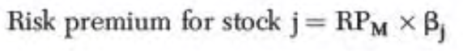
Equation 15
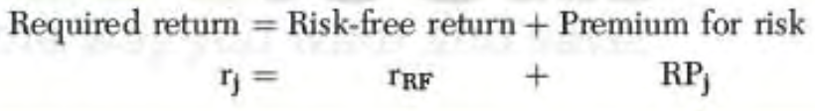
Equation 16
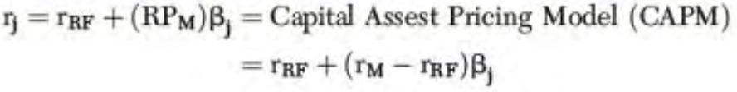
Equation 17
Security market line (SML): The line that shows the relationship between risk as measured by beta and the required rate of return for individual securities.
- Required rates of return are shown on the vertical axis, and risk is shown on the horizontal axis
- Risk-free securities have B_{j} = 0; therefore, r_{RF} appears as the vertical axis intercept
- The slope of the SML reflect the degree of risk aversion in the economy. The greater the average investor’s aversion to risk, the steeper the slope of the line. The greater the risk premium for any stock, the higher the required rate of return on stocks

The Impact of Inflation
R_{RF} is the price of money to a risk-free borrower.

The risk-free rate as measured by the rate on US Treasury securities is called the nominal (quoted) rate, and it consists of 2 elements: 1) a real inflation-free rate of return and 2) an inflation premium equal to the anticipated average rate of inflation.

Under CAPM, the increase in r_{RF} also causes an equal increase in the rate of return on all risky assets because the inflation premium is built into the required rate of return of both risk-free and risky assets.

Changes in Risk Aversion
The slope of the security market line reflects the extent to which investors are averse to risk. The steeper the slope of the line, the greater the average investor’s risk aversion. As risk aversion increases, so does the risk premium and, therefore, so does the slope of the SML.

Changes in a Stock’s Beta Coefficient
A firm can affect its beta risk by changing the composition of its assets and by modifying its use of debt financing. External factors, such as increased competition can also alter a company’s beta. When such changes occur, the required rate of return changes as well, which affects the stock price.

A Word of Caution
- The CAPM model was developed under very restrictive assumptions:
  - All investors have the same information
  - Everyone can borrow and lend at the risk-free rate of return
  - Stocks can be purchased in any denomination of fraction of shares
  - Taxes and transaction costs do not exist
- The entire theory is based on ex ante (expected) conditions, yet only ex post (past) data is available

Stock Market Equilibrium

We can use the CAPM to find the required return for an investment, which we designate as r_{Q}.

Expected rate of return: 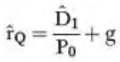

Equilibrium: The condition under which the expected return on a security is just equal to its required return, and the price is stable.

2 conditions must hold in equilibrium:
- The expected rate of return as seen by the marginal investor must equal the required rate of return
- The actual market price of the stock must equal its intrinsic value as estimated by the marginal investor

Different Types of Risk

Rate of return (interest) = r = risk-free rate + risk premium
= r_{RF} + RP
= [r* + IP] + [DRP + LP + MRP]

r = Quoted (nominal) rate
r_{RF} = Nominal risk-free rate of return
r* = Real risk-free rate interest
IP = Inflation premium
DRP = Default risk premium
LP = Liquidity (marketability) premium
MRP = Maturity risk premium

According to the CAPM, investors should not expect to be rewarded for all of the (total, stand-alone) risk associated with an investment because some risk can be eliminated through diversification. The relevant risk is that portion of the total risk that cannot be diversified away.
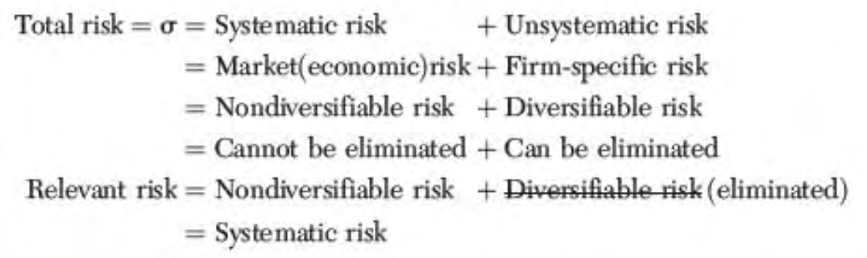
… 4
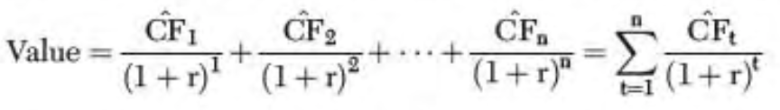
Equation 18
The value of an asset is based on the cash flows that the asset is expected to generate during its life and the rate of return investors require to put up their money to purchase the investment.


Capital Budgeting Techniques

Importance of Capital Budgeting

A number of factors combine to make capital budgeting decisions among the most important decisions:
- The impact of capital budgeting is long term
- Asset expansion is fundamentally related to expected future sales
  - If the firm invests too much in assets, it will incur unnecessarily heavy expanses
- Timing is also important, capital assets must be ready to come when they are needed
- Effective capital budgeting can improve both the timing of asset acquisitions and the quality of assets purchased
  - A firm that forecasts its needs for capital assets in advance will have an opportunity to purchase and install the assets before they are needed
- Capital budgeting is important because the acquisition of fixed assets typically involves substantial expenditures
  - Before a firm can spend a large amount of money, it must have funds available

Generating Ideas for Capital Projects

The same general concepts developed for valuing financial assets are involved in capital budgeting. However, whereas a set of stocks and bonds already exists in financial markets, capital budgeting projects are created by the firm.

Project Classifications
- Replacement decisions: Whether to purchase capital assets to take the place of existing assets to maintain or improve existing operations.
- Expansion decisions: Whether to purchase capital projects and add them to existing assets to increase existing operations.
- Independent projects: Projects whose cash flows are not affected by decisions made about other projects.
  - All independent projects can be purchased if they all are acceptable
- Mutually exclusive projects: A set of projects in which the acceptance of one project means the others cannot be accepted.
  - Only one mutually exclusive project can be purchased, even if they all are acceptable.

Similarities Between Capital Budgeting and Asset Valuation

To make capital budgeting decisions, assets that are being evaluated must be valued.
- Estimate the cash flows expected to be generated by the asset during its life.
- Evaluate the riskiness of the projected cash flows to determine the appropriate rate of return to use for computing the present value of the estimated cash flows.
- Compute the present value of the expected cash flows
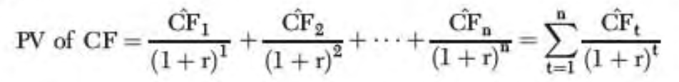
- Compare the present value of the future expected cash flows with the initial investment (cost) required to acquire the asset.

If a firm identifies (creates) an investment opportunity with a present value greater than its cost, the value of the firm will increase by purchasing the investment. There is a direct link between capital budgeting and stock values: The more effective the firm’s capital budgeting procedures, the higher the price of its stock.

Net Present Value (NPV)

Net present value (NPV): The present value of an asset’s future cash flows minus its purchase price (initial investment).

If the net benefit computed on a present value basis (NPV) is positive, then the asset (project) is considered an acceptable investment.

NPV Decision Rule: A project is acceptable if NPV > $0
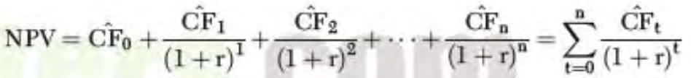
Equation 19 NPV
Financial Calculator: Use the cash flow register.
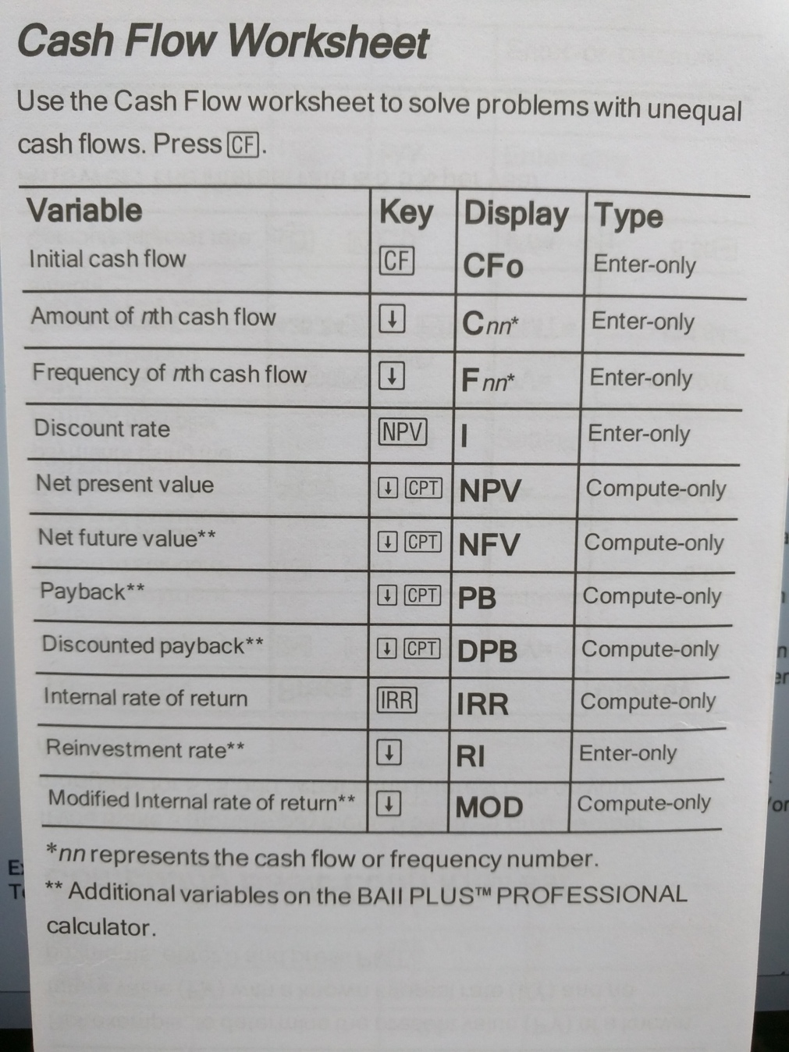
Financial Calculator 17 BAII Plus Cash Flow
A NPV of 0 signifies that the project’s cash flows are just sufficient to repay the investment capital and to provide the required rate of return (r) on that capital.

In general, a project is considered acceptable if its NPV is positive; not acceptable if its NPV is negative.

Internal Rate of Return (IRR)

Internal rate of return (IRR): The discount rate that forces the PV of a project’s expected cash flows to equal its initial cost; IRR is similar to the YTM on a bond.

As long as the project’s IRR, which is its expected return, is greater than the rate of return required by the firm for such an investment, the project is acceptable.

IRR Decision Rule: A project is acceptable if IRR > r
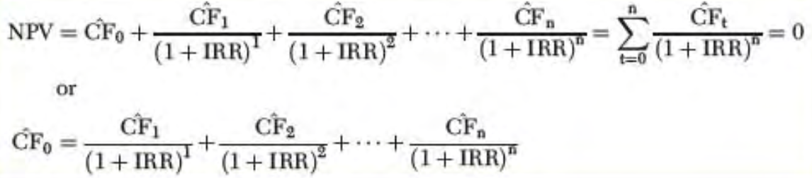
Equation 20 IRR
Financial Calculator: Follow the steps used to find the NPV and simply press IRR when solving.

Required rate of return (Hurdle Rate): The discount rate (cost of funds) that the IRR must exceed for a project to be considered acceptable.

You do not need to know a firm’s required rate of return (r) to solve for IRR.
- IRR is the rate of return that will be earned by anyone who purchases the project
- The IRR is dependent on the project’s cash flow characteristics, not the firm’s required rate of return
  - The IRR of a particular project is the same for all firms, regardless of their particular required rates of return.
  - Taking on a project whose IRR exceeds its required rate of return, or cost of funds, increases shareholder’s wealth.

Comparison of the NPV and IRR Methods

Using the IRR method could lead to investment decisions that increase but do not maximize wealth.

NPV Profiles: A curve showing the relationship between a project’s NPV and various discount rates (required rates of return)

Because the IRR is defined as the discount rate at which a project’s NPV equals zero, the point where its NPV profile crosses the x axis indicated a project’s internal rate of return.

NPVs and the Required Rate of Return
Crossover rate: The discount rate at which the NPV profiles of two projects cross and, thus, at which the project’s NPVs are equal.

Independent Projects
Mathematically, the NPV and IRR methods will always lead to the same accept/reject decisions for independent projects: If a project’s NPV is positive, its IRR will exceed r; if NPV is negative, r will exceed the IRR. Note the following:
- The IRR criterion for acceptance is that the required rate of return is less than (to the left of) the IRR.
- Whenever the required rate of return is less than the IRR, NPV > 0.

If a project is acceptable using the IRR method, then the NPV method also will show it is acceptable.

Mutually Exclusive Projects
If two projects are mutually exclusive rather than independent, then only one project can be purchased.

Two basic conditions can cause NPV profiles to cross and thus lead to conflicts between NPV and IRR:
- When project size (scale) difference exist (cost)
- When timing differences exist (timing of cash flows)

The value of early cash flows depends on the rate at which said cash can be reinvested. The NPV method implicitly assumes that the rate at which cash flows can be reinvested is the required rate of return, r, whereas the IRR method implies that the firm has the opportunity to reinvest at the project’s IRR.

NPV method assumes that cash flows can be reinvested at the required rate of return, whereas the IRR method assumes reinvestment at the project’s IRR.

Reinvestment rate assumption: The assumption that cash flows from a project can be reinvested
- at the cost of capital, if using the NPV method, or
- at the internal rate of return, if using the IRR method

When projects are independent, the NPV and IRR methods both provide exactly the same accept/reject decisions.

Cash Flow Patterns and Multiple IRRs

A project has a conventional cash flow pattern if it has cash outflows (cost) in one or more consecutive periods at the beginning of its life followed by a series of cash inflows. Otherwise it has an unconventional cash flow pattern.
… 5 cash flow patterns

Multiple IRRs: The situation in which a project has two or more IRRs.

There exists an IRR solution for each time the direction of the cash flows associated with a project is interrupted.

Modified Internal Rate of Return

Modified IRR (MIRR): The discount rate at which the present value of a project’s cost is equal to the present value of its terminal value, where the terminal value is found as a the sum of the future values of the cash inflows compounded at the firm’s required rate of return.
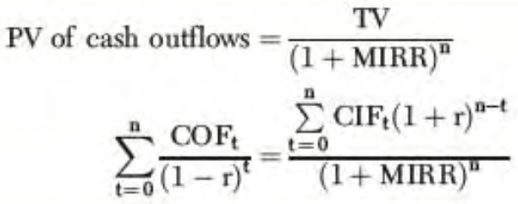
Equation 21 COF = cash outflows / CIF = cash inflows / left term in 2nd line is the PV of the investment outlays (cash outflows) when discounted at the project’s required rate of return (r) / numerator on the right term is the FV of the cash inflows / The future value of the cash inflows is also called the terminal value (TV)
Financial calculator: Use CF, enter PV, FV, N, and compute for I/Y to obtain MIRR.

The modified IRR has a significant advantage over traditional IRR measure.
- MIRR assumes that cash flows are reinvested at the required rate of return, whereas the traditional IRR measure assumes that cash flows are reinvested at the project’s own IRR
- MIRR is a better indicator of a project’s true profitability
- MIRR solves the multiple IRR problem
- If 2 projects are of equal size and have the same life, then NPV and MIRR will always lead to the same project selection decision
- If 2 projects are of equal size but differ in lives, the MIRR will always lead to the same decision as the NPV if the MIRRs for both projects are calculated using as the terminal year the life of the longer project
- If the projects differ in size, conflicts can still occur
- MIRR is superior to the regular IRR as an indicator of a project’s true rate of return or expected long-term rate of return
- NPV provides a better indicator of the extent to which each project will increase the value of the firm

Payback Period – Traditional (Nondiscounted) and Discounted

Traditional payback period (PB): The length of time it takes for the original cost of an investment to be recovered from its expected cash flows.

The exact payback period can be found using the formula:
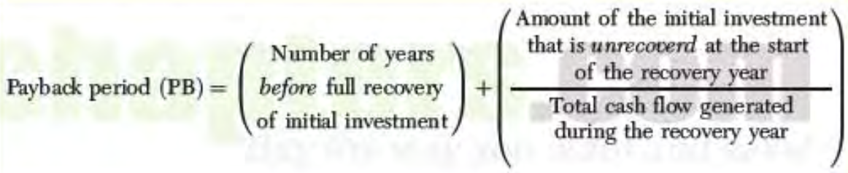
Equation 22 Payback Period
Using payback to make capital budgeting decisions is based on the concept that it is better to recover the cost of a project sooner rather than later.

As a general rule, a project is considered acceptable if its payback is less than the maximum cost recovery time established by the firm.

Traditional Payback Period (PB) Decision Rule: A project is acceptable if PB < n*
n* is the recovery period

- Because payback ignored the TVM, relying solely on this method could lead to incorrect decisions.
- When payback is used, the cash flows beyond the payback period are ignored.

Discounted payback period (DPB): The length of time it takes for a project’s discounted cash flows to repay the cost of the investment

Discounted Payback (DPB) Decision Rule: A project is acceptable if DPB < Project’s life

Conclusions on the Capital Budgeting Decision Methods

Traditional payback and discounted payback provide information about both the risk and the liquidity of a project. A long payback means:
- That the investment dollars will be locked up for many years (illiquid)
- That the project’s cash flows must be forecast far out into the future (high risk)
- Analogy: An investor should never compare the yields to maturity on two bonds without considering their terms to maturity because a bond’s riskiness is significantly influenced by its maturity

- NPV is the best single measure of profitability, followed by IRR, which contains information concerning a project’s safety margin, which is not inherent in NPV.
- The NPV contains no information about either the safety margin inherent in a project’s cash flow forecast or the amount of capital at risk, but the IRR does.
- The IRR method has a reinvestment assumption that probably is unrealistic, and its possible to have multiple IRRs. These problems can be corrected by using MIRR

Because they are all easy to calculate, all methods should be considered in the decision process.

The Postaudit

Postaudit: A comparison of the actual and expected results for a given capital project. Involves:
- Comparing actual results with those predicted
- Explaining why any differences occurred

The postaudit has 2 main purposes:
- Improve forecasts: When decision makers are forced to compare their projections with actual outcomes, there is a tendency for estimates to improve.
- Improve operations: When a divisional team has made a forecast about an investment, its members are putting their reputations on the line.

The postaudit is not a simple process, a number of factors can cause complications:
- Each element of the cash flow forecast is subject to uncertainty
- Projects sometimes fail to meet expectations for reasons beyond the control of the operating executives and for reasons that no one could realistically be expected to anticipate
- It is often difficult to separate the operating results of one investment from those of a larger system
- It is often hard to hand out blame or praise because the executives who were actually responsible for a given decision might have moved on by the time the results of long-term investments are known

Project Cash Flows and Risk

Cash Flow Estimation

Cash flow: The actual cash, as opposed to accounting net income, that a firm receives or pays during some specified period.

The relevant cash flows include the investment outlays needed to purchase the project and the net cash flows the project is expected to generate after it is purchased.

If cash flow estimates are not reasonably accurate, any analytical technique can lead to poor decisions and hence to operating losses and lower stock prices.

The financial staff’s role in the forecasting process includes:
- Coordinating the efforts of the other departments such as engineering and marketing
- Ensuring that everyone involved with the forecast uses a consistent set of economic assumptions
- Making sure that no biases are inherent in the forecasts

Relevant Cash Flows

Relevant cash flows: The specific cash flows that should be considered in a capital budgeting decision. This process can be rather difficult, but two cardinal rules should be followed:
- Capital budgeting decisions must be based on cash flows after taxes, not accounting income
- Only incremental cash flows are relevant to the accept/reject decision

Cash Flow versus Accounting Income
After-tax cash flows, not accounting profits, are used because it is cash that pays the bills and can be invested in capital projects, not profits.

Although accounting profits are important for some purposes, only cash flows are relevant for the purposes of setting a value on a project. Cash flows can be reinvested to create value, profits cannot.
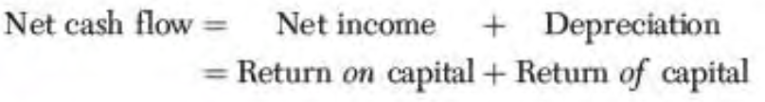
Equation 23 Net Cash Flow

Incremental Cash Flow: The change in a firm’s net cash flow attributable to an investment project.
- Sunk Costs: A cash outlay that already has been incurred and that cannot be recovered regardless of whether the project is accepted or rejected.
- Opportunity Cost: The return on the best alternative sue of an asset; the highest return that will not be earned if funds are invested in a particular project.
- Externalities: The effect that accepting a project will have on the cash flows in other parts (areas) of the firm
- Shipping and Installation Costs: When a firm acquires fixed assets, it often must incur substantial costs for shipping and installing the equipment. These charges are added to the invoice price of the equipment.
  - The depreciable basis of an asset (total amount that can be depreciated during the asset’s life) includes the purchase price and any additional expenditures required to make the asset operational, including shipping and installation.
  - The full cost of the equipment, including shipping and installation costs, is used as the depreciable basis when depreciation charges are calculated
  - Depreciation is a noncash expense, so there is not a cash outflow associated with the recognition of depreciation expense each year. But because depreciation is an expense, it affects the taxable income of a firm, thus the amount of taxes paid by the firm, which is a cash flow.
- Inflation: Inflation is a fact of life, and should be recognized in capital budgeting decisions.
  - If expected inflation is not built into the determination of expected cash flows, the calculated NPV and IRR will be incorrect.
  - Expected inflation should be reflected in the revenue and cost figures, and thus the annual net cash flow forecasts
  - The required rate of return does not have to be adjusted for inflation expectation because investors include such expectations when establishing the rate at which they are willing to allow the firm to use their funds

Beyond Incremental Cash Flows

In most cases, we can classify a project’s incremental cash flows as follows:
- Cash flows that occur only at the start of the project’s life (period 0)
- Cash flows that continue throughout the projects life (periods 1 through n)
- Cash flows that occur only at the end of the project (period n)

If a cash flow does not change, it is not relevant for the capital budgeting analysis.

Initial Investment Outlay: Includes the incremental cash flows associated with a project that will occur only at the start of a project’s life.

CF_{o} includes such cash flows as the purchase price of a new project and shipping and installation costs.
- Replacement decision: The initial investment must also take into account the cash flows associated with the disposal of the old (replaced) asset
- Addition or replacement of capital asset also affects the firm’s short-term assets and liabilities, known as the working capital accounts
- Net working capital is the difference between current assets and current liabilities
- The difference between the required increase (decrease) in current assets and the spontaneous increase (decrease) in current liabilities is the change in net working capital

The change in net working capital that results from the acceptance of a project is an incremental cash flow that must be considered in the capital budgeting analysis.

Incremental Operating Cash Flows: The changes in day-to-day cash flows that result from the purchase of a capital project and continue until the firm disposes of the asset.

The incremental operating cash flows for each year can be computed directly by using:
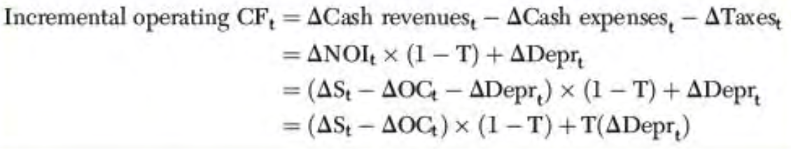
Equation 24 Incremental operating cash flows – ∆ = change / ∆NOI = Change in net operating income in period t / ∆Depr = Change in depreciation in period t / ∆S = Change in sales revenues in period t / ∆OC = Change in operating costs, excluding depreciation, in period t / T = marginal tax rate
Depreciation is a noncash expense.

The change in depreciation expense needs to be computed because, when depreciation changes, taxable income changes and so does the amount of income taxes paid; and the amount of taxes paid is a cash flow

Terminal Cash Flow: The net cash flow that occurs at the end of the life of a project, including the cash flows associated with
- The final disposal of the project
- Returning the firm’s operations to where they were before the project was accepted.

The terminal cash flow includes the salvage value and the tax impact of the disposition of the project.

Capital Budgeting Project Evaluation

Expansion Project: A project that is intended to increase sales.

Analysis of the Cash Flows
- Summarize the initial investment outlay required for the project
  - The initial cash flows consist of the purchase price of the needed equipment, the cost of shipping and installation, and the required investment in NWC
- Estimate the cash flows that will occur once production begins
- Computer the terminal cash flow

The total net cash flow is the sum of the incremental cash flow for the year and the terminal cash flow. In the final year of a project’s economic life, the firm incurs 2 types of cash flows:
- The incremental operating cash flow attributed to the project’s normal operation
- The terminal cash flow associated with the disposal of the project

Replacement Analysis: An analysis involving the decision as to whether to replace an existing asset with a new asset.

The analysis relating to replacements is the same as for expansion projects (identify the relevant cash flows and then find the NPV of the project) but identifying the incremental cash flows associated with a replacement project is more complicated because the cash flows both from the new asset and from the old asset must be considered.

The cash flows associated with the new asset will take the place of the cash flows associated the old asset.

Analysis of Cash Flows
When a replacement asset is purchases, the asset being replaced must be removed from operations.
- If the asset can be sold it will generate a positive cash flow, otherwise the cash flow will be negative.
- If the firm disposes of the old asset a value different from it book value, there will be a tax effect equal to: capital loss (gain) * tax
- Compute the incremental operating cash flow each year. Determine how operating cash flows will change if the new machine is purchased to replace the old.
- The change in depreciation expense must be computed to determine the impact such change will have on the taxes paid by the firm

Incorporating Risk in Capital Budgeting Analysis

Three separate and distinct types of project risk need to be examined to determine whether the required rate of return used to evaluate a project should be different from the average required rate of the firm:
- Stand-alone risk: The risk an asset would have if it were a firm’s only asset; it is measured by the variability of the asset’s expected returns.
- Corporate (within-firm) risk: Risk that does not take into consideration the effects of stockholders’ diversification; it is measured by a project’s effect on the firm’s earnings variability.
- Beta (market) risk: That part of a project’s risk that cannot be eliminated by diversification; it is measured by the project’s beta coefficient.

Stand-Alone Risk

Stand-alone risk is of great importance for 3 reasons:
- It is easier to estimate a project’s stand-alone risk than either its corporate or beta risk.
- In the vast majority of cases, all 3 types of risk are highly correlated. Stand-alone risk generally is a good proxy for hard-to-measure corporate and beta risks.
- If management wants a reasonably accurate assessment of a project’s riskiness, it should spend considerable effort on determining the riskiness of the project’s own cash flows, thus stand-alone risk.

- The starting point for analyzing a project’s stand-alone risk involves determining the uncertainty inherent in the project’s cash flows.
- The sales quantity and the sales price estimates are expected values taken from probability distributions.
- The nature of the individual cash flow distribution, and their correlations with one another, determines the nature of the NPV distribution, and the project’s stand-alone risk.

Sensitivity Analysis: A risk analysis technique in which key variables are changed and the resulting changing in the NPV and the IRR are observed.
- Begin with the base-case situation developed using the expected values for each input
- Each variable is changed by specific % points above and below the expected value, NPV is then calculated for each value
- The set of NPVs is plotted against the variable that was changed

The steeper the slope, the more sensitive the NPV is to a change in the variable.

Scenario Analysis: A risk analysis technique in which bad and good sets of financial circumstances are compared with a most likely (base case) situation.

In general, a project’s stand-alone risk depends on both the sensitivity of its NPV to changes in key variables AND the range of likely values of these variables as reflected in their probability distributions.

Worst-case scenario: An analysis in which all of the input variables are set at their worst reasonably forecasted values.

Best-case scenario: An analysis in which all of the input variables are set at their best reasonably forecasted values.

Base (most likely) case: An analysis in which all of the input variables are set at their most likely values.

To carry out the scenario analysis:
- Use the worst(best)-case variable values to obtain the worst(best)-case NPV
- Use the result of the scenario analysis to determine the expected NPV, standard deviation of NPV, and the coefficient of variation
- Estimate the probabilities of occurrence of the 3 scenarios, the Pr_{i} values.

Monte Carlo Simulation: A risk analysis technique in which probable future events are simulated on a computed, generating a probability distribution that indicates the most likely outcomes.
- More complicated than scenario analysis because the probability distribution of each uncertain cash flow variable has to be specified
- A value from the probability distribution for each variable is randomly chosen to compute the project’s cash flows
- These values are then used to determine the project’s NPV

Corporate (Within-Firm) Risk

To measure corporate (within-firm) risk, we need to determine how the capital budgeting project is related to the firm’s existing assets.

Adding new projects that are not highly related to existing assets can help reduce corporate risk and fluctuations associated with sales.

Corporate risk is important for 3 primary reasons:
- Undiversified stockholders are more concerned about corporate risk than about beta risk
- Empirical studies of the determinants of required rates of return (r) generally find that both beta and corporate risk affect stock prices
- The firm’s stability is important to its managers, workers, customers, suppliers, and creditors, as well as to the community in which it operates.

Corporate risk is important even if a firm’s stockholders are well diversified.

Beta (Market) Risk

Previous risk measures do not take account of portfolio risk, and they don’t specify whether a project should be accepted or rejected. The capital asset pricing model (CAPM) can be used to help overcome these shortcomings.

Beta (Market) Risk and Required Rate of Return for a Project
Systematic risk is the relevant risk of a stock because unsystematic (firm-specific) risk can be reduced significantly or eliminated through diversification.

Project required rate of return r_{proj}: The risk-adjusted required rate of return for an individual project.
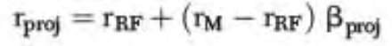
Equation 25 Adjusted CAPM

- The SML is a security market line like the one developed in the Stocks chapter. The higher the beta risk, the higher the rate of return needed to compensate investors for bearing the risk.
- High-risk investments require higher rates of return
- If the expected rate of return on a given capital project lies above the SML, the expected rate of return on the project is more than enough to compensate for its risk, and the project should be accepted.

Measuring Beta Risk for a Project
Pure play method: An approach used for estimating the beta of a project in which a firm identifies companies whose only business is the product in question, determines the beta for each firm, and then averages the betas to find an approximation of its own project’s beta.

Project Risk Conclusions

- Well-diversified investors should be concerned only with beta risk, managers with stock price maximization, and these 2 factors should lead to the conclusion that beta risk should be given virtually all the weight in capital budgeting decisions.
- If investors are not well diversified, if the CAPM does not operate exactly as theory says it should, or if measurement problems keep managers from having confidence in the CAP approach in capital budgeting, it might be appropriate to give stand-alone and corporate risk more weight.
- CAPM ignores bankruptcy costs, even though such costs can be substantial, and that the probability of bankruptcy depends on a firm’s corporate risk, not on its beta risk.
- Assuming that stand-alone and corporate risk are highly correlated (typical), the project’s stand-alone risk will be a good measure of its corporate risk.
- Assuming that beta and corporate risk are highly correlated (typical), a project with more corporate risk than average will also have more beta risk, and vice versa.

How Project Risk is Considered in Capital Budgeting Decisions

Risk-adjusted discount rate: The discount rate (required rate of return) that applies to a particular risky stream of income; it is equal to the risk-free rate of interest plus a risk premium appropriate to the level of risk associated with a particular project.

Risk adjustments are necessarily judgmental and somewhat arbitrary.

Many companies use a two-step procedure to develop risk-adjusted discount rates for use in capital budgeting analysis.
- The overall required rate of return is established for the firm’s existing assets
  - This process is completed on a division by division basis for very large firms (perhaps using CAPM)
- All projects generally are classified into three categories: high risk, average risk, low risk
  - The firm or division uses the average required rate of return as the discount rate for average-risk projects, reduces the average rate by 1 or 2 % when evaluation low risk projects, and raises it for high risk projects.

If project risk is not considered in capital budgeting analysis, incorrect decisions are possible.

Capital Rationing

Capital rationing: A situation in which a constraint is placed on the total size of the firm’s capital investment.

A firm that subjects itself to capital rationing is deliberately forgoing profitable projects, and hence it is not truly maximizing its value.

Multinational Capital Budgeting

Differences for foreign firms:
- Cash flow estimation generally is much more complex for overseas investments.
  - Most multinational firms set up a separate subsidiary in each foreign country they operate and the relevant cash flows for these subsidiaries are the dividend and royalties repatriated.
  - Repatriation of earnings: The process of sending cash flows from a foreign subsidiary back to the parent company
- These cash flows must be converted into the currency of the part company and are subject to future exchange rate changes.
- Dividends and royalties normally are taxed by both foreign and home-country governments.
  - Foreign governments might restrict the amount of cash that can be repatriated

The cash flows relevant for the analysis of a foreign investment are the cash flows that the subsidiary legally can send back to the parent.

The rate of return required for a foreign project might be different than for an equivalent domestic project because foreign projects might be either riskier or less risky. A higher risk could arise from 2 primary sources:
- Exchange rate risk: The uncertainty associated with the price at which the currency from one country can be converted into the currency of another country.
- Political risk: The risk of expropriation (seizure) of a foreign subsidiary’s assets by the host country or unanticipated restrictions on cash flows to the parent company
  - Generally, political risk premiums are not added to the required rate of return.

Companies can take steps to reduce the potential loss from expropriation in three major ways:
- By financing the subsidiary with capital raised in the country in which the asset is located
- By structuring operations so that the subsidiary has value only as part of the integrated corporate system
- By obtaining insurance against economic losses from expropriation from a source such as the Overseas Private Investment Corporation (OPIC)
  - Insurance premiums would have to be added to the project’s cost

